Administration Guide

*RsMd – IBM Privileged Identity & Access Management*

Version 2.0

February 5, 2016

Document Control

**Document Version and Revision History**

This section lists document versions.

|  |  |  |  |
| --- | --- | --- | --- |
| **Date** | **Version** | **Author** | **Nature of Change** |
| 1/20/2016 | 1.0 | Jim Emerson | Doc created. |
| 2/5/2016 | 2.0 | Jim Emerson | Minor edits |

**Approval**

This section can be used to signoff approval for this technical design.

|  |  |  |
| --- | --- | --- |
| Role/Job Title | Name | Approval & Date |
| Project Manager | tbd |  |
| Director Enterprise Architecture | tbd |  |
| IT Infrastructure Manager | tbd |  |
| Security Analyst | tbd |  |

Table of Contents

1 DOCUMENT INFORMATION 7

1.1 Purpose 7

1.2 Audience 7

1.3 Definitions, Acronyms and Abbreviations 7

1.4 Related Documents 7

1.5 Scope 7

2 ENVIRONMENT 7

2.1 Production Environment 8

2.1.1 Activity 8

2.2 Development Environment 8

2.2.1 Activity 9

2.3 Administrative Domains 10

2.4 User Groups 10

2.4.1 PIM Administrator 10

2.4.2 Privileged Administrator 10

2.4.3 Privileged User 11

3 PIM CONSOLES 11

4 PIM SERVICE CENTER TASKS 12

4.1 Creating Identify Providers 12

4.1.1 Create a Linux Identity Provider 12

4.1.2 Add an Active Directory Identity Provider 16

4.1.3 Configure Local Windows Identity Provider 17

4.2 Managing Resources 18

4.2.1 Add a Resource 18

4.2.2 Edit a Resource 19

4.3 Managing Credentials 20

4.3.1 Add New Credentials 20

4.3.2 Edit Credentials 23

4.3.3 Associate Credentials to Identity Providers 24

4.3.4 Check In Credentials 28

4.3.5 Reset Passwords 29

4.4 Managing Access 31

4.4.1 Create a New Access Policy 31

4.4.2 Edit a Policy 34

4.4.3 Delete a Policy 36

5 PIM ADMINISTRATIVE CONSOLE TASKS 38

5.1 Log In 38

5.2 Managing Credential Vault 39

5.2.1 Add New Credentials 39

5.3 Managing Credential Pools 41

5.3.1 Create a Credential Pool 41

5.3.2 Modify a Credential Pool 43

5.3.3 View Credentials in a Pool 44

5.3.4 Bulk Loading Credentials into the Vault 46

5.4 Managing Shared Access Policies 47

5.4.1 Create a Shared Access Policy 47

5.4.2 Disable a Shared Access Policy 51

5.5 Managing Requests 53

5.5.1 Viewing Requests 53

5.6 Managing Users and Roles 55

5.6.1 Creating Users 55

5.6.2 View Roles 58

5.6.3 Creating Roles 59

6 APPLIANCE DASHBOARD TASKS 63

6.1 Log In 63

6.2 Restarting or Shutting Down an Appliance 64

6.3 Configuring Directory/Database Server 64

6.4 Viewing Logs 65

6.5 Managing Clusters 66

6.5.1 Manually Synchronize Clusters 66

7 SESSION RECORDER CONSOLE TASKS 67

7.1 Log In 67

7.2 View Session Recordings 67

8 APPENDIX 68

8.1 PosixLinuxProfile 68

8.2 ADProfile 68

8.3 WinlocalProfile 69

8.4 Configuring Shared Access Workflows 69

8.5 Bulk Upload CSV File 70

**Blank Page**

# DOCUMENT INFORMATION

## Purpose

The document is an administrator’s guide for the RsMd Privileged Identity & Access Management (PIAM) system.

## Audience

This document is intended to be read and approved by individuals with the following roles:

* PIAM Administrators

## Definitions, Acronyms and Abbreviations

| **Term/Acronym/Abbreviation** | **Meaning** |
| --- | --- |
| ESSO | Enterprise Single Sign On |
| PIAM | RsMd Privileged Identify and Access Management |
| PIM | IBM Privileged Identify Manager (also known as “IBM Privileged Identity Security Manager”) |

## Related Documents

| **Document Identifier** | **Title** |
| --- | --- |
| Tivoli Software Redbook publication | *Centrally Managing and Auditing Privileged User Identities by Using the IBM*  *Integration Services for Privileged Identity Management* at  http://www.redbooks.ibm.com/redpapers/pdfs/redp4660.pdf. |

## Scope

The guide provides information PIAM administrators need to manage the system. These sections focus on:

* PIAM Environment
* Consoles
* Administrator Tasks
  + Service Center Tasks
  + Administrative Console Tasks
  + Appliance Dashboard Tasks
  + Session Recorder Console Tasks
* Key System Configurations

# ENVIRONMENT

RsMd has developed a privileged identity and access management application based on IBM Privileged Identity Manager (PIM) 2.0. This section introduces the environmental architecture, focusing on the production, development, administrative domains, and user groups.

## Production Environment

The RsMd PIAM Production environment includes three identical instances of PIM deployed in EU, AP and US. In each instance, the activity represented below occurs.

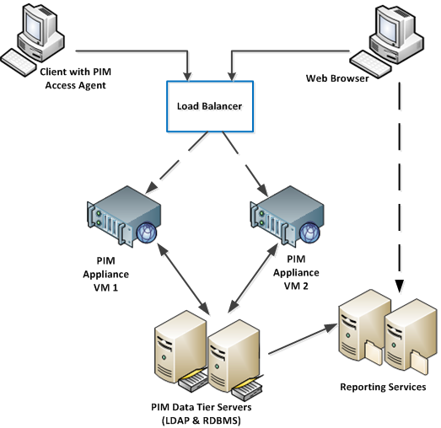

Figure 1. PIAM Production Activity

### Activity

As figure 1 indicates, users working with Client running AccessAgent and a web browser access PIM via a Load Balancer. The Load Balancer distributes the requests to two virtual PIM Appliances. The Appliances send data requests to PIM Data Tier Servers (hosting LDAP and RDBMS). The Data Tier Servers respond, returning requested data to the Appliances. The Data Tier Servers also send records of the data exchange to the Reporting Services. Records of the Web Browser’s requests are sent to the Reporting Services.

## Development Environment

The RsMd PIAM Development environment is a scaled down version of a regional Production instance. It includes the following components:

* PIM Virtual Appliance 1: US1-PAMAPP-D01.CORP.RSMD.ORG
* PIM Virtual Appliance 2: US1-PAMAPP-D02. CORP.RSMD.ORG
* LDAP/DB2 Server: US1-PAMLDP-D01.CORP.RSMD.ORG
* Reporting Server: US1-PAMRPT-D01.CORP.RSMD.ORG
* AD Adapter Server: US1-PAMADS-D01.CORP.RSMD.ORG

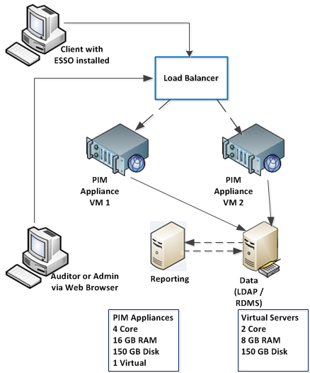

Figure 2. PIAM Development Activity

### Activity

As figure 2 shows, a Client with Enterprise Single Sign On (ESSO) installed send a data request to the PIM Appliances via the Load Balancer. An Auditor or Admin machine sends a request via a Web Browser. The Load Balance distributes the requests to the two PIM Appliances. The Appliances pass requests to the Data server (running LDAP and RDMS). The Reporting server requests records of data requests from the Data server. The Data server responds. An Auditor or Administrator sends requests to the system via the Load Balancer.

**Note**: ESSO services are used to store and transmit encrypted user credentials to local and network destinations including domains. ESSO credentials are stored in a Credential database. Because ESSO is a generic service, user credentials stored in the ESSO database can be used to access applications produced by multiple vendors.

## Administrative Domains

The DEV environment includes three Administrative Domains for each RsMd region: three for AM, three for AP, and three for EU. Each Administrative Domain is managed by an Administrative who used PIAM options to control credential-related policies, services, and user privileges within that domain.

**Note**: By contrast, the Production environment has one Administrative Domain for each PIM instance.

The following screen image shows the RsMd DEV Environment with three PIM instances; for America, Asia-Pacific, and Europe offices.

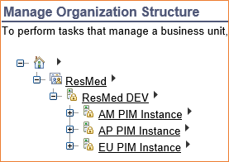

Figure 3. DEV – Three PIM Instances

## User Groups

Administrators manage three types of PIAM user groups: PIM Administrator, Privileged Administrator, and Privileged User.

### PIM Administrator

The PIM Administrator generally manages all RsMd PIM instances.

### Privileged Administrator

A Privileged Administrator can access all PIAM to add, modify, and manage:

* Credentials and credential pools
* Resources and identity providers
* Shared access policies

### Privileged User

A Privileged User accesses PIAM to:

* Request access to a resource
* Check in/out accounts using the PIM Self-Service Console.
* Manually check in/out accounts
* Use AccessAgent to single sign on to systems and applications.

When AccessAgent is used, account check in/out is automatic.

# PIM CONSOLES

Users access PIM and perform tasks on the consoles listed below.

|  |  |  |  |
| --- | --- | --- | --- |
| **Console** | **URL** | **Users** | **Description** |
| SSO Console | https://<FQDN of server>/admin/ | PIM Administrator | Used to manage policies and tasks related to single-sign on. |
| PIM Service Center | https://<FQDN of server>/ispim/ | Privileged Administrator | Used to manage an Administrative domain containing credentials, resources and identity providers. |
| Administrative Console | https://<FQDN of server>/itim/console/main | Privileged Administrator | Used to perform administrative tasks such as managing roles, policies, credential pools, and users. |
| Self Service Console | https://<FQDN of server>/itim/selfq | Privileged User | Used for personal tasks including requesting access to roles and checking in/out shared credentials. |
| Virtual App Dashboard | https://<FQDN of server> | Administrator | Provides status information, statistics and access to logs. |
| Session Recorder Console | **Error! Hyperlink reference not valid.** of server>/recorder/ui | Security Administrator | Used to search and review recordings. |

# PIM SERVICE CENTER TASKS

Administrators use Service Centers to perform tasks in their domains.

## Creating Identify Providers

An Administrator must create an identity provider for a user whose credentials will exist in several places (AD, Linux, Windows, etc.). The identity provider can be used to change passwords across the multiple systems and validate credentials in the multiple systems. The following sections explain how to create Linux, Active Directory (SD), and Local Windows Provider Identity Providers.

### Create a Linux Identity Provider

This section shows how to setup an identity provider for a Linux environment.

To create the identity provider:

1. Launch a browser and specify the following URL:

**Error! Hyperlink reference not valid.**

1. Enter the Administration credentials for the domain and click **Log In**.

For example:

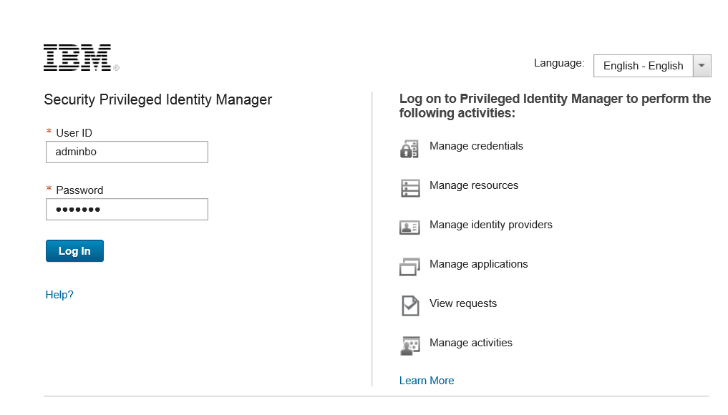

Figure 4. PIM Log In

1. When the Home page opens, click **Manage Identity Providers**.

For example:

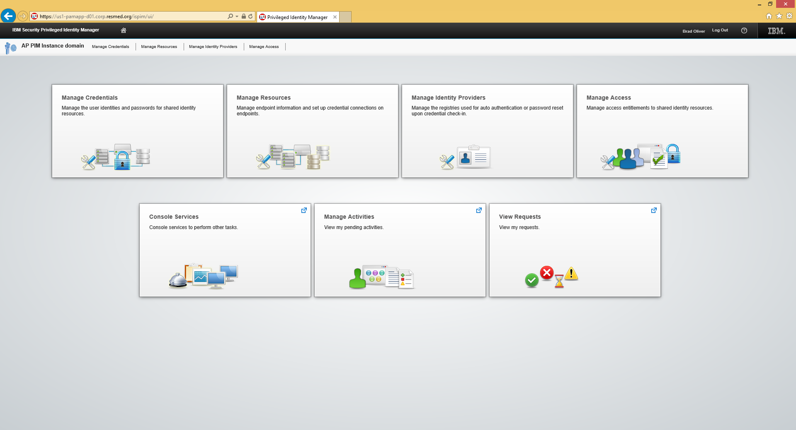

Figure 5. PIM Options

1. When the Manage Identity Providers page opens, click **Add**.

For example:

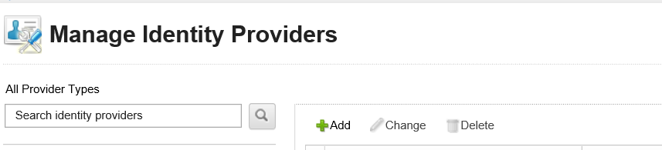

Figure 6. Manage Identity Providers +Add Selection

The provider page is loaded with possible provides.

For example:

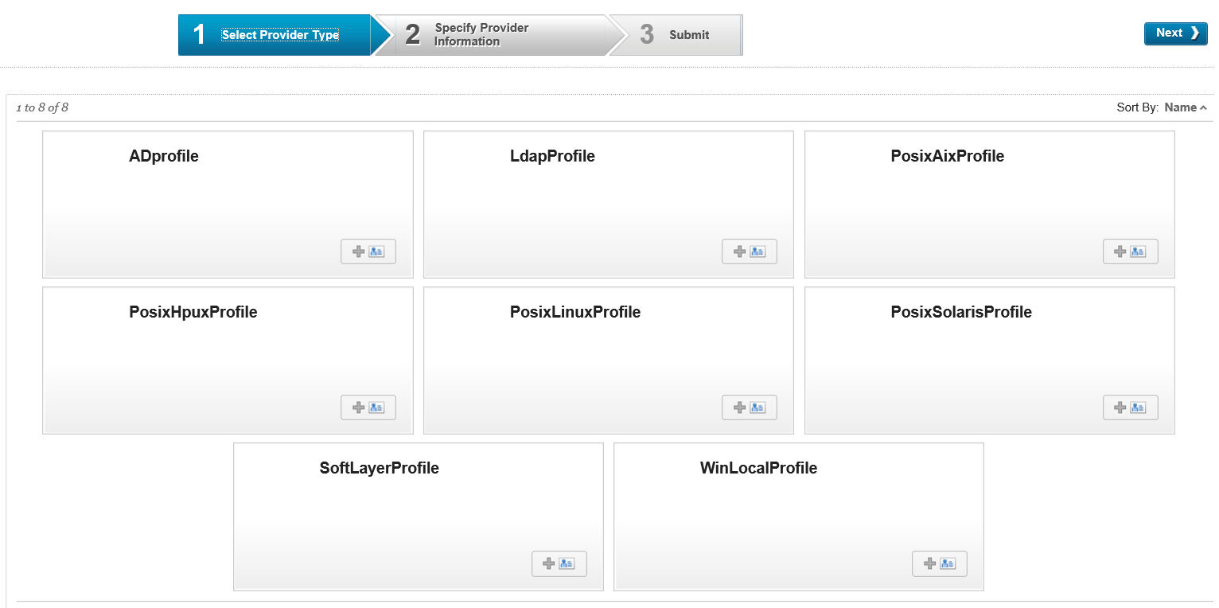

Figure 7. Manage Identity Providers Add Options

1. Click **PosixLinuxProfile**.
2. When the Profile page opens, fill in the field identified by an asterisk (*).

See section 8.1 PosixLinuxProfile for possible field values. For example:

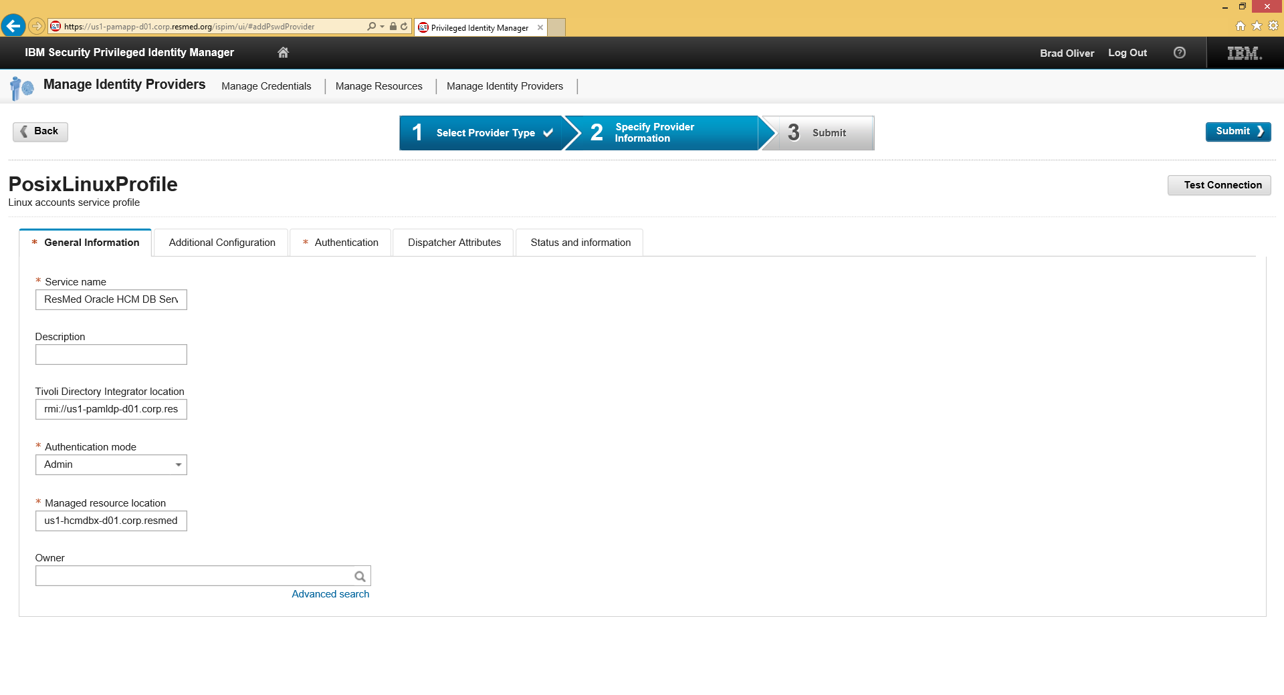

Figure 8. Manage Identity Providers PosixLinuxProfile Page

1. On the Linux Profile page, select the **Authentication** tab.

For example:

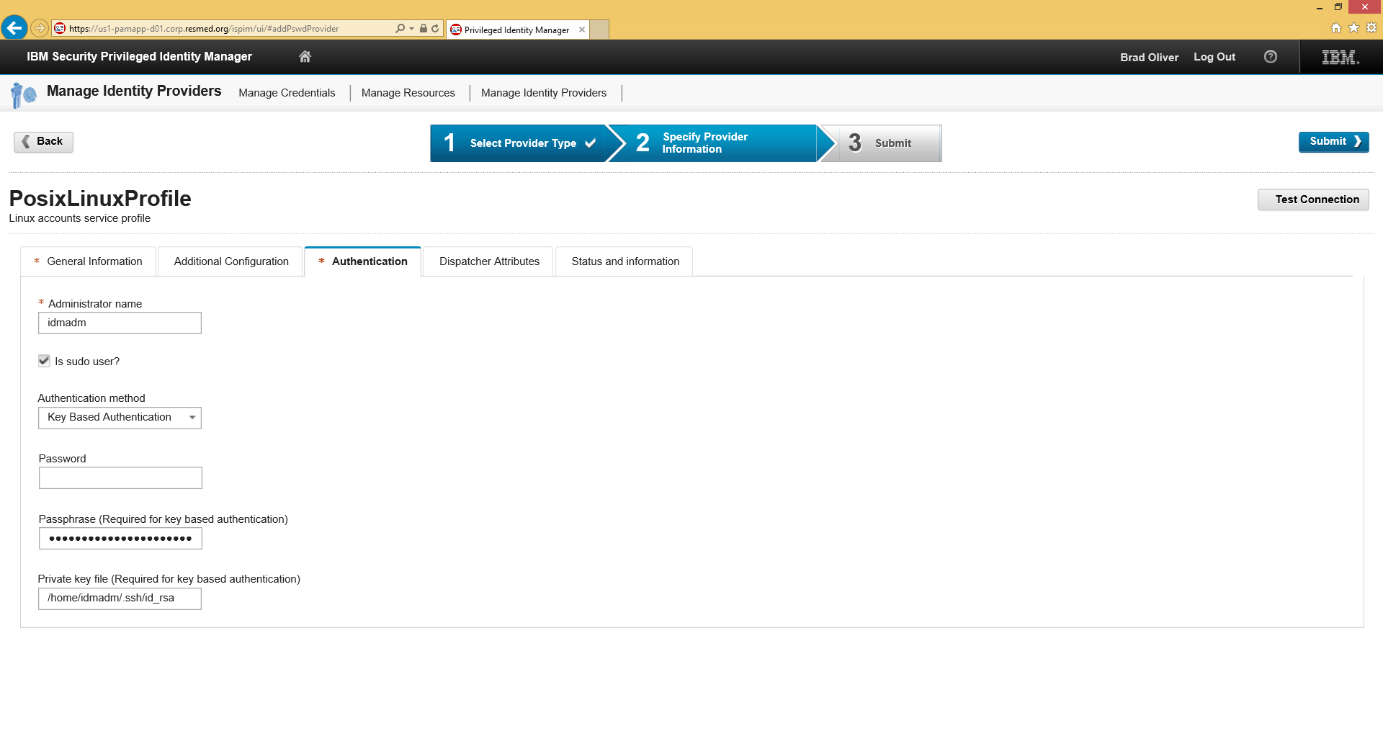

Figure 9. PosixLinuxProfile Authentication Tab

1. Fill in the blank fields and click **Submit**.

See section 8.1 PosixLinuxProfile for possible field values.

1. Test the connection by clicking the **Test Connection** button.
2. When the test is successful, click **Submit** to save the configuration.

For example:

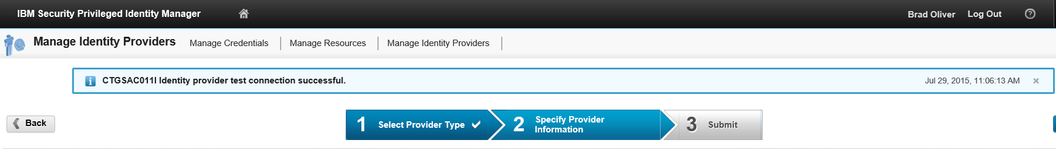

Figure 10. Manage Identity Providers Submit

The Manage Identity Providers page shows the addition. For example:

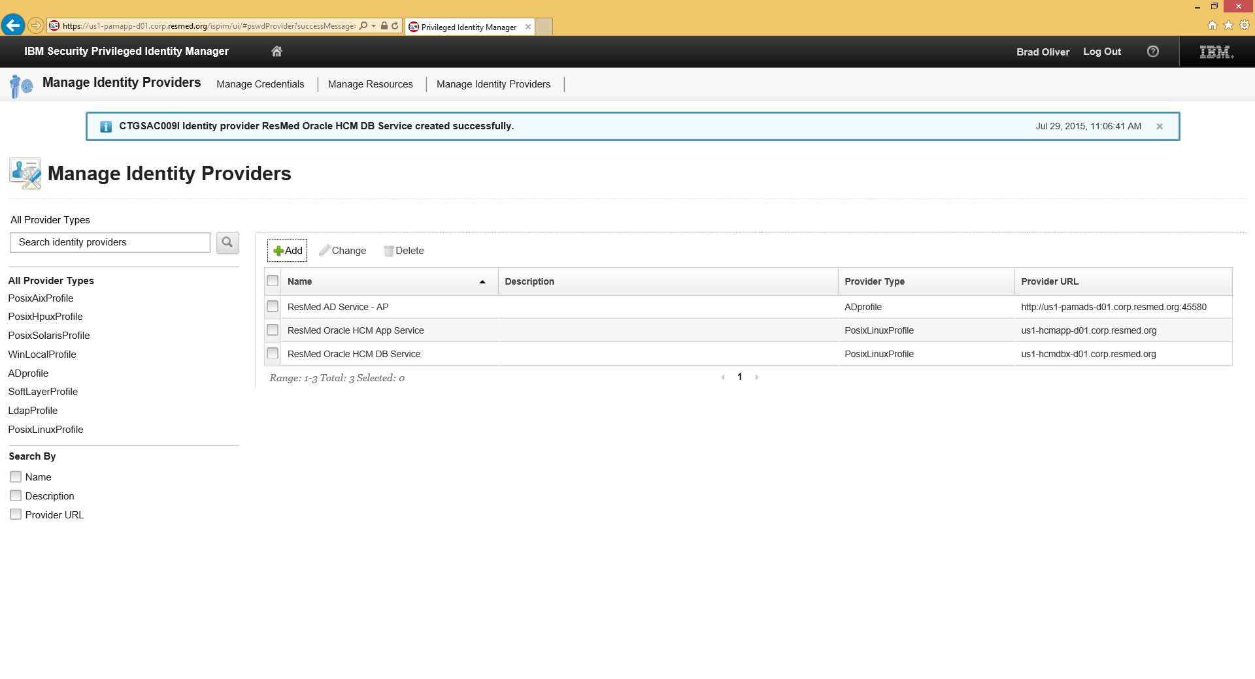

Figure 11. Manage Identity Providers Configuration Saved

### Add an Active Directory Identity Provider

This section explains how to add an Active Directory (AD) Provider.

To add an AD Provider:

1. Launch a browser and specify the following URL:

**Error! Hyperlink reference not valid.**

1. Enter the Administration credentials for the domain and click **Log In**.

See Figure 4. PIM Log In.

1. On the Home page, click the **Manage Identity Provider** option.

See Figure 5. PIM Options.

1. When the Manage Identity Provider page appears, click **+Add**.

See Figure 6. Manage Identity Providers +Add Selection.

1. On the next page, click **ADProfile**.

See Figure 7. Manage Identity Providers Add Options.

1. When the Profile page opens, fill in the field identified by an asterisk (*) and then, click **Submit**.

For possible field values, see section 8.2 ADProfile.

For example:

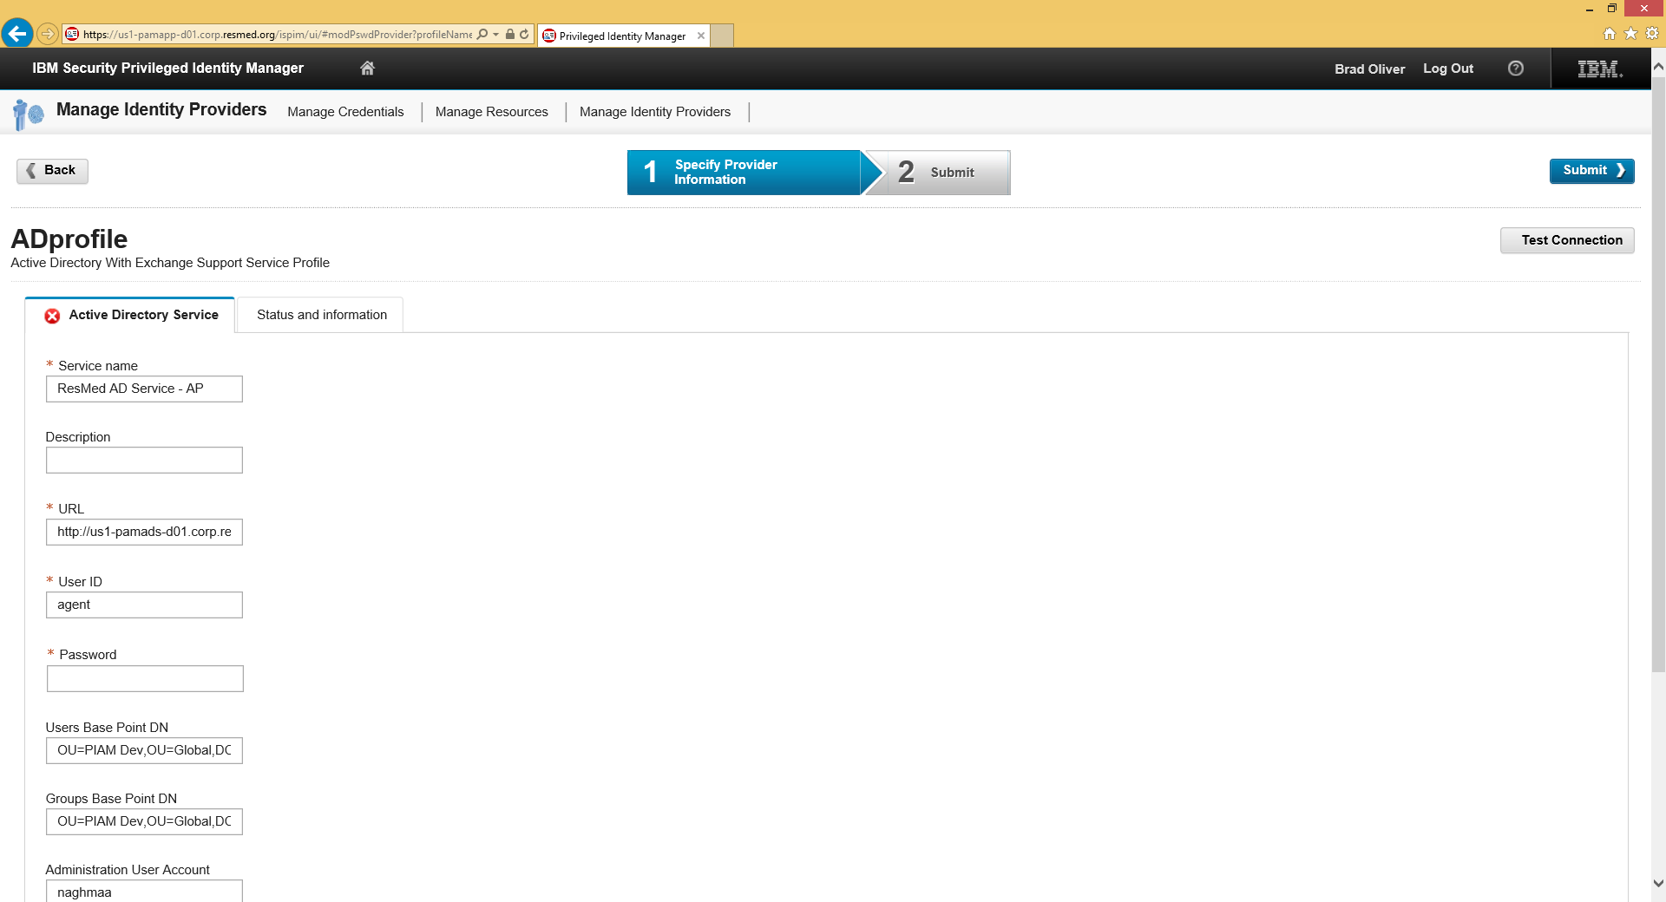

Figure 12. ADProfile Submit

### Configure Local Windows Identity Provider

If accounts are local on a server, the Administrator configures WinLocalProfile.

1. Launch a browser and specify the following URL:

**Error! Hyperlink reference not valid.**

1. Enter the Administration credentials for the domain and click **Log In**.

See .

1. On the Home page, click the **Manage Identity Provider** option.

See Figure 5. PIM Options.

1. When the Manage Identity Provider page appears, click **+Add**.

See .

1. On the next page, click **WinLocalProfle**.

See .

1. When the Profile page opens, fill in the field identified by an asterisk (*) and then, click **Submit**.

For possible field values, see section 8.3 WinlocalProfile.

For example:

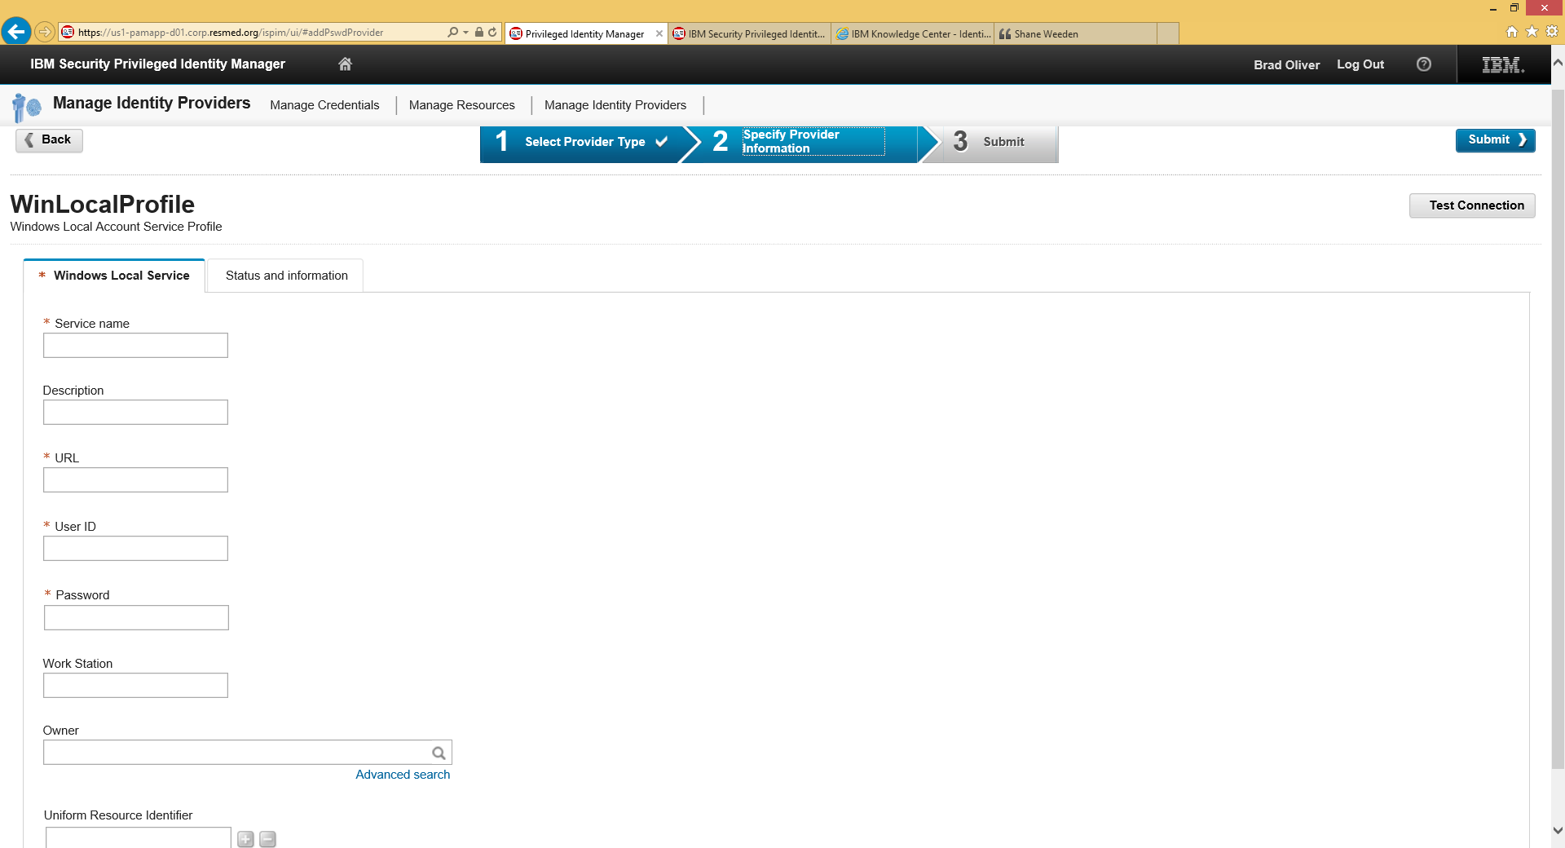

Figure 13. WinLocalProfile Page

## Managing Resources

A resource is a host or end point that is accessed through shared credentials. Resources may include RsMd AD, RsMd AD Servers – AP, RsMd AirView – Dev, RsMd Oracle HCM Servers, RsMd Windows Servers – AP, etc. An Administrator adds a new resource using PIM and associates it with a credential.

The following sections explain how to add and edit resources.

### Add a Resource

To add a resource:

1. Launch a browser and specify the following URL:

**Error! Hyperlink reference not valid.**

1. Enter the Administration credentials for the domain and click **Log In**.

See .

1. On the Home page, click the **Manage Resources** option.

See Figure 5. PIM Options.

1. When the Manage Resources page appears, click **+Add**.

For example:

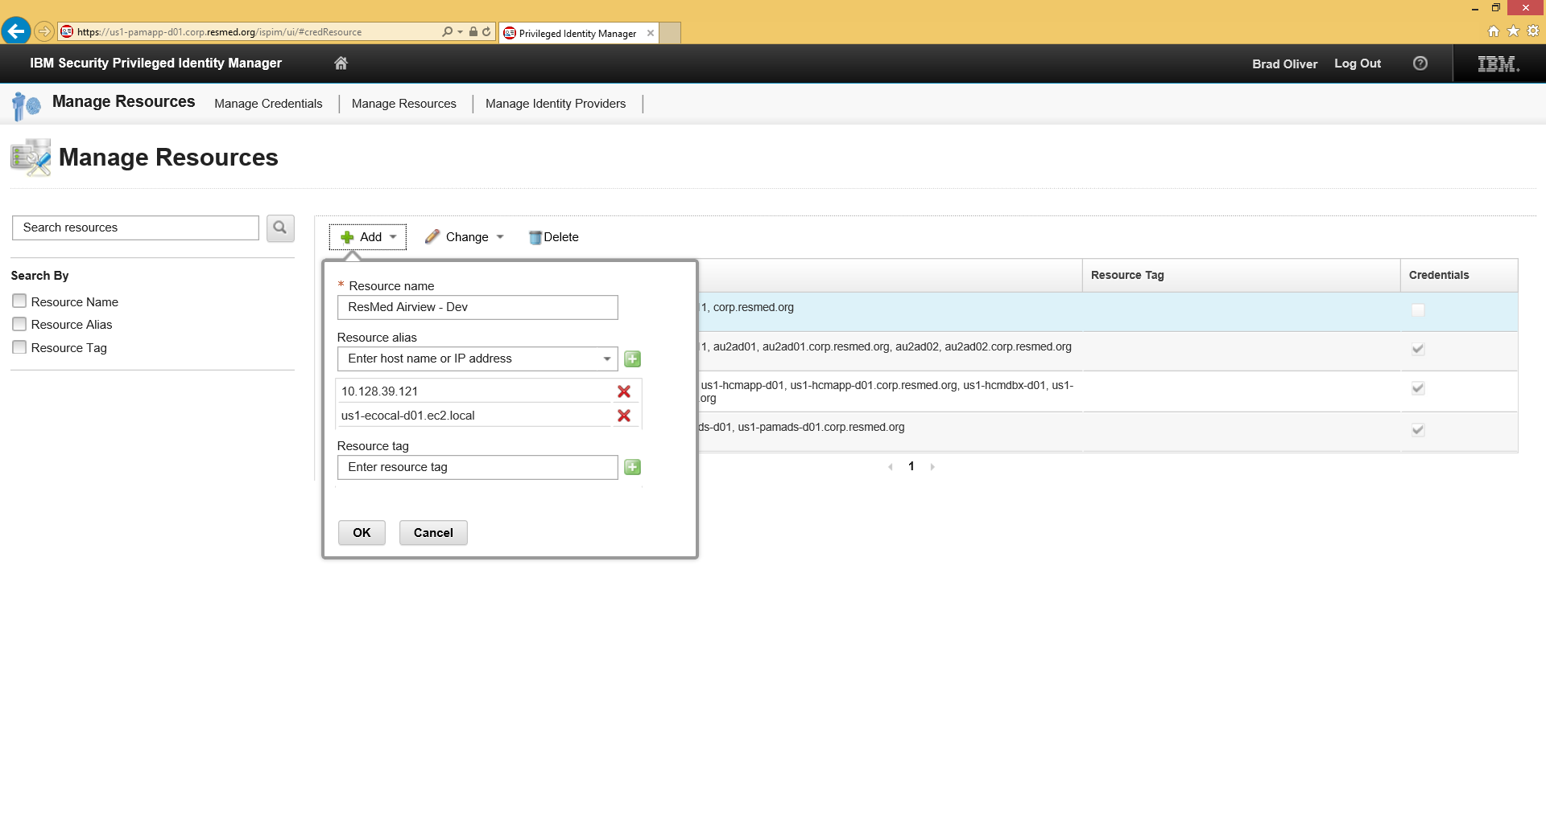

Figure 14. PIM Manage Resources +Add

1. Enter a Resource Name and Resource Alias.

The Resource Alias is a host name or IP address of the host.

1. Click the green button after both the Resource Name and Alias fields.



1. Click **OK**.

A message indicates that the resource was successfully created.

For example:

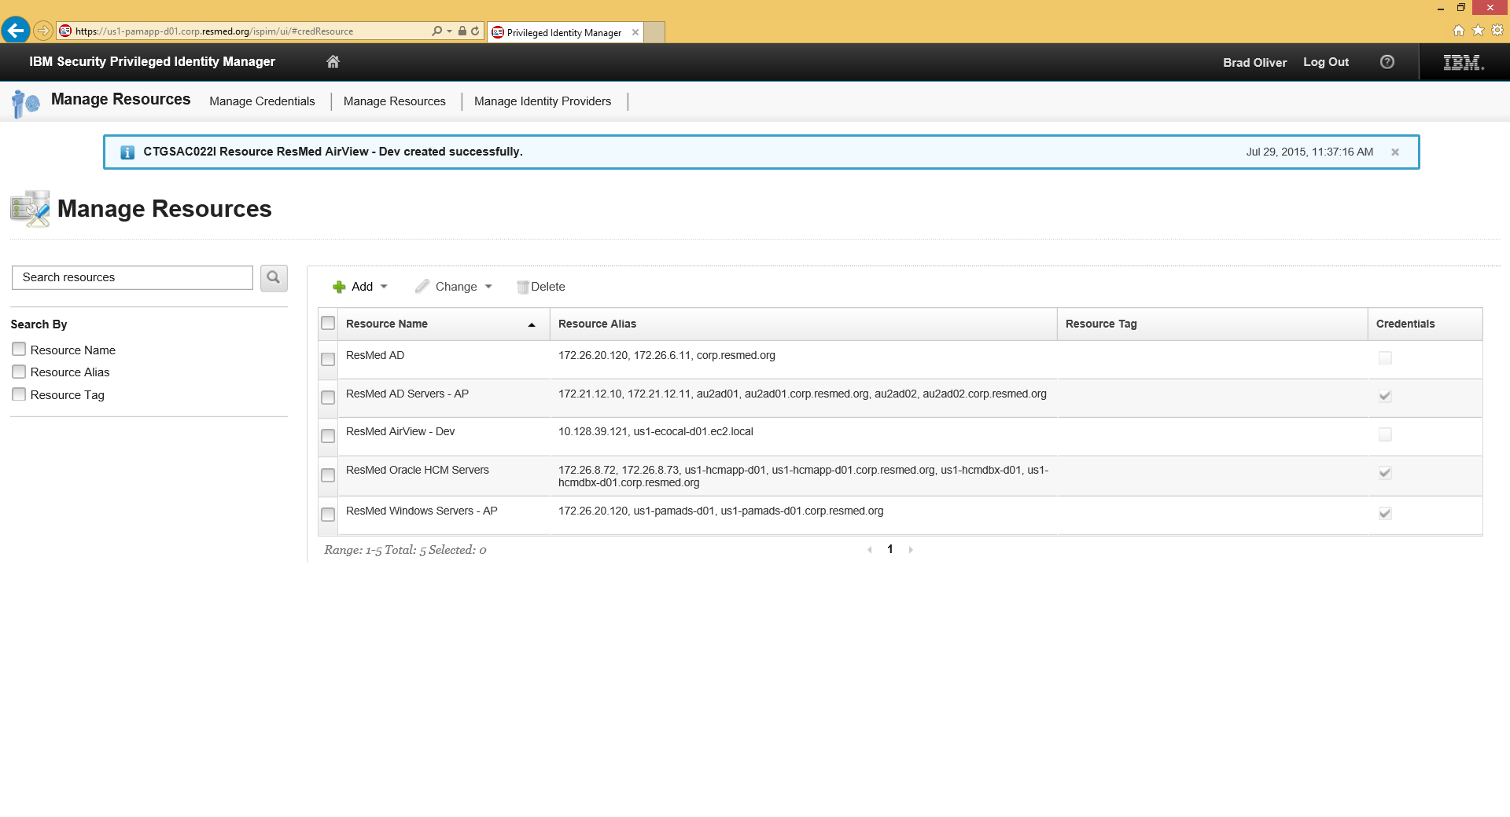

Figure 15. PIM Manage Resources - Success

### Edit a Resource

To edit a resource:

1. On the Manage Resources page, click on the check box next to the resource name.
2. Click the **Change** option.

The drop down box enables you to modify the name, add an alias, or delete a name.

For example:

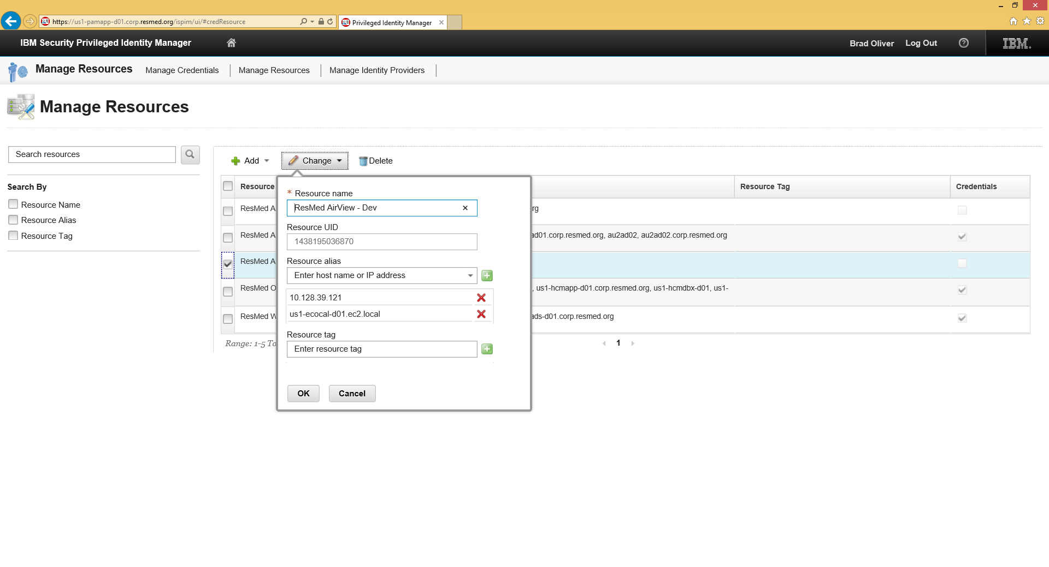

Figure 16. PIM Manage Resources - Change

1. Enter your change and click **OK**.

A message at the top notes that your changes are saved.

For example:

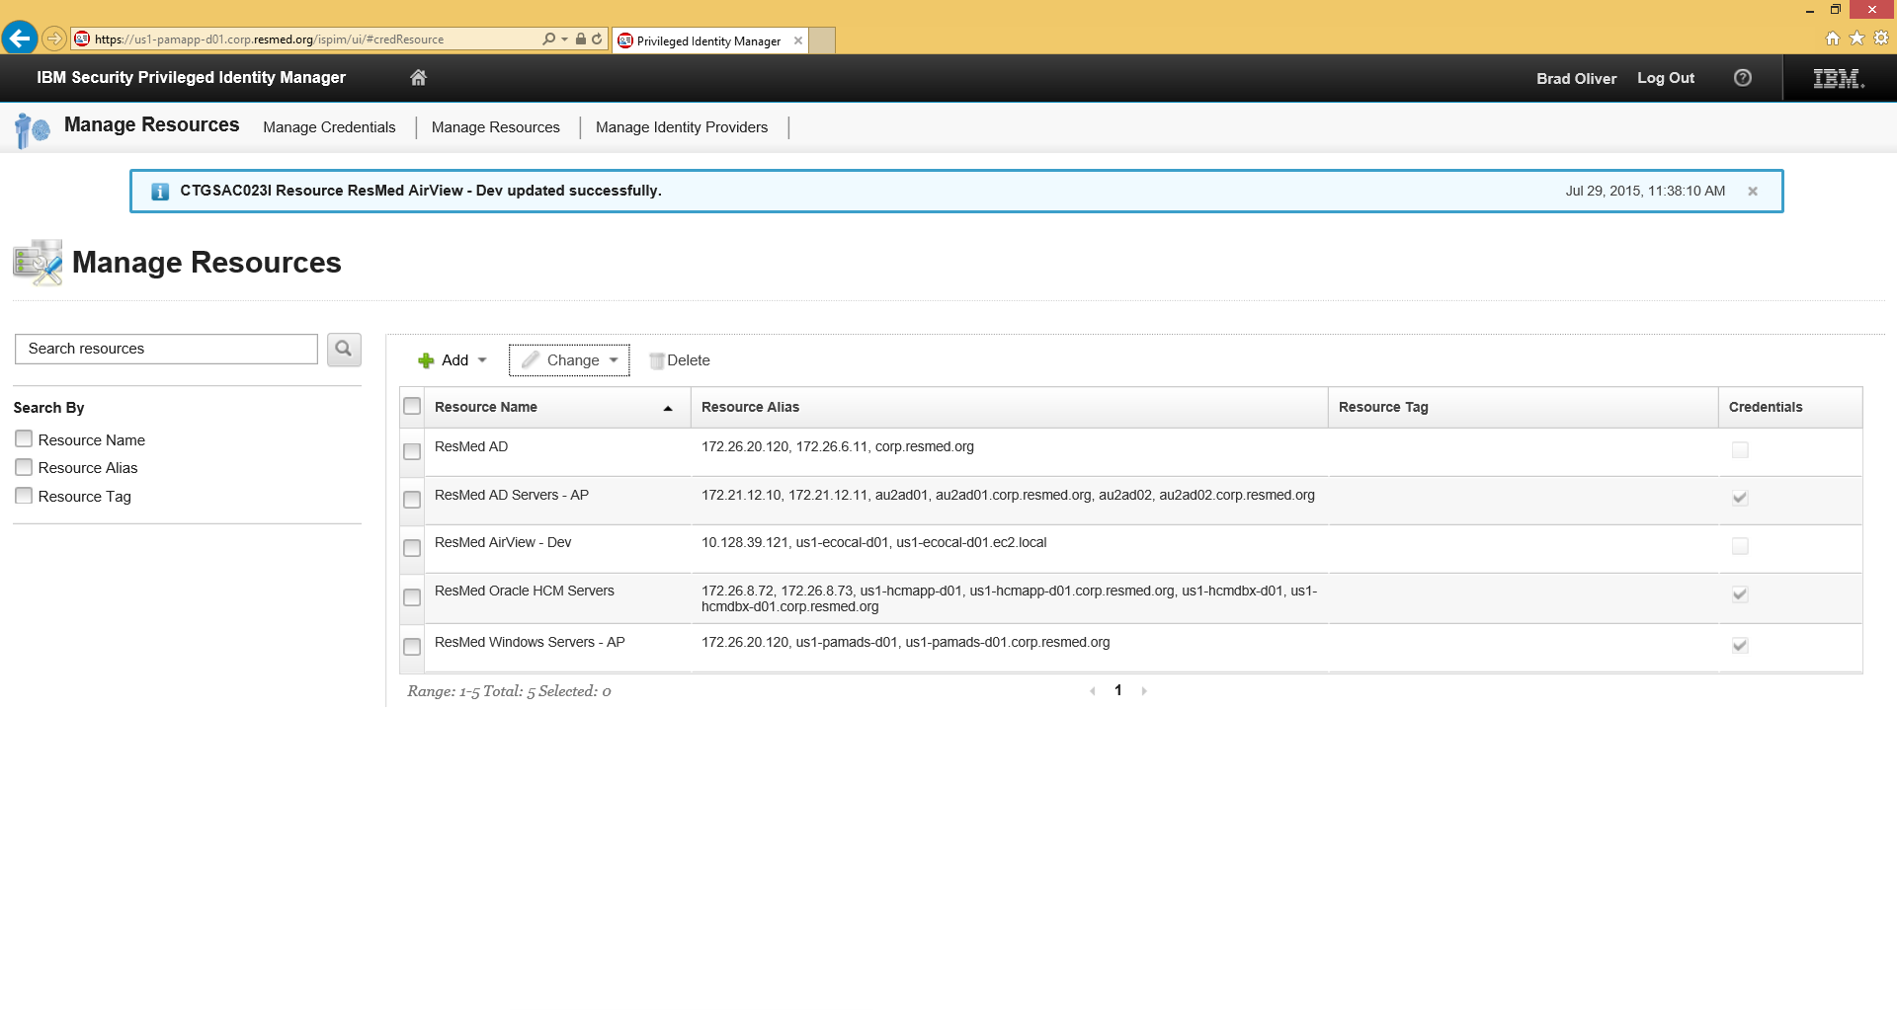

Figure 17. PIM Manage Resources - Change Success

## Managing Credentials

Administrators use PIM to manage shared credentials. This section explains how to add and edit credentials.

### Add New Credentials

To add new credentials:

1. Launch a browser and specify the following URL:

**Error! Hyperlink reference not valid.**

1. Enter the Administration credentials for the domain and click **Log In**.

See .

1. On the Home page, click the **Manage Credentials** option.

See .

1. When the Manage Credentials page appears, click **+Add**.

For example:

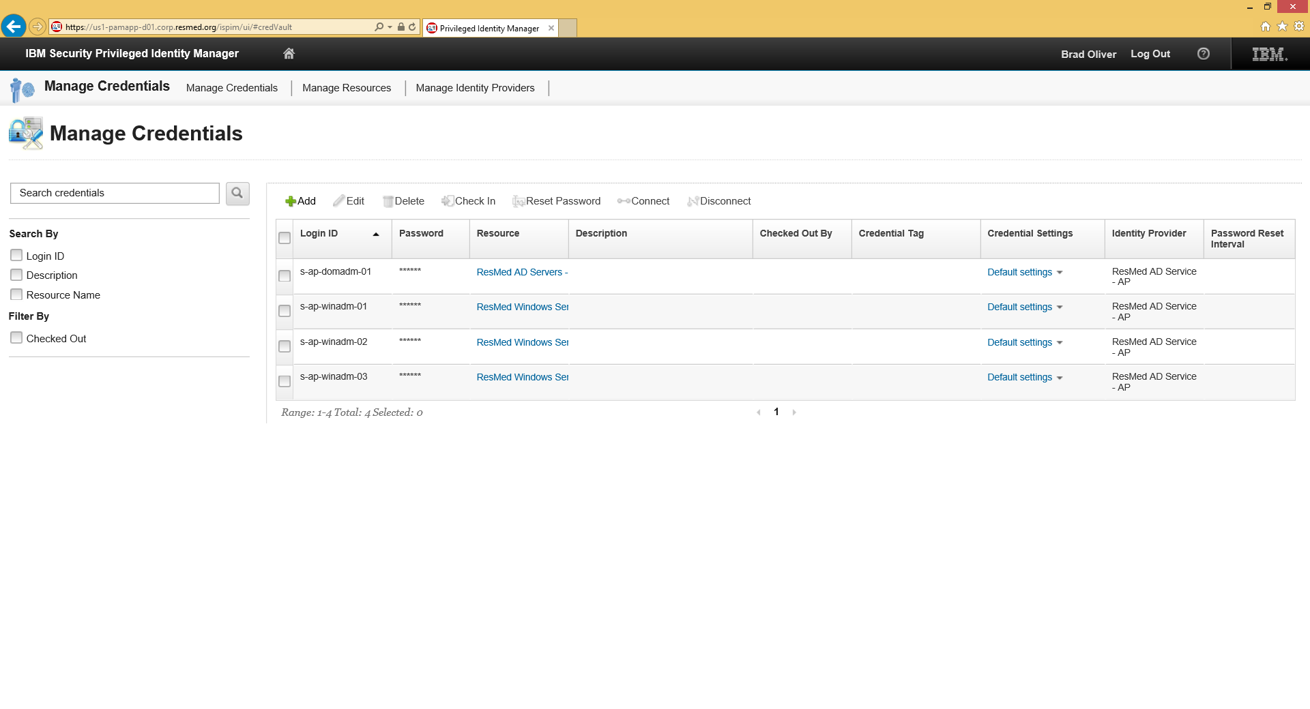

Figure 18. PIM Manage Credentials +Add

1. When the Add Credentials page appears, enter the login ID (e.g., adminna2), password, and resource.

**Note**: The system validates the Password entry. If it is incorrect or the field is blank, changes will not be saved.

For example:

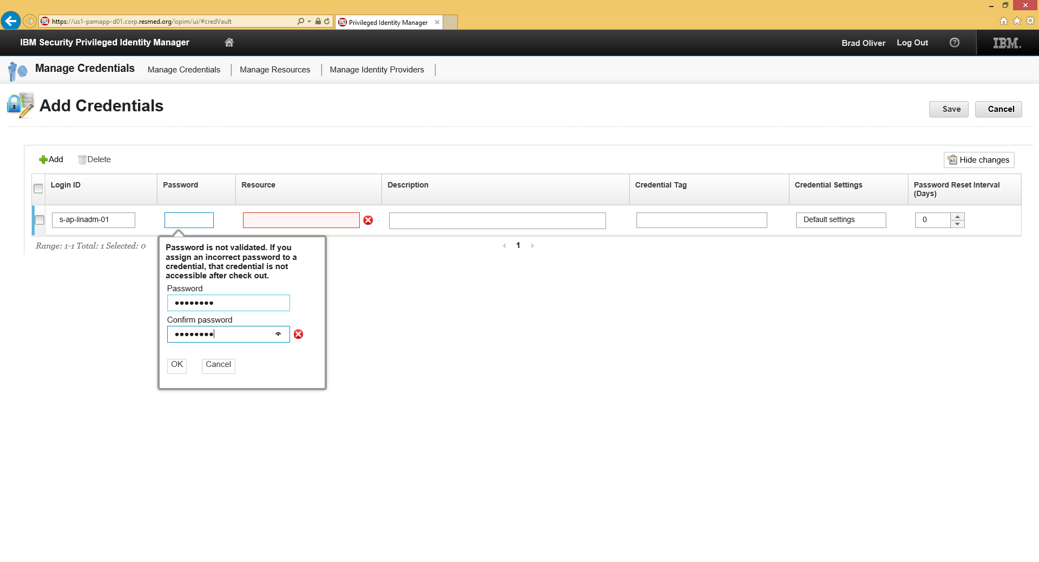

Figure 19. PIM Manage Credentials – Add Credentials Password Validation

1. Select an available resource from the drop-down menu and click **OK**.

For example:

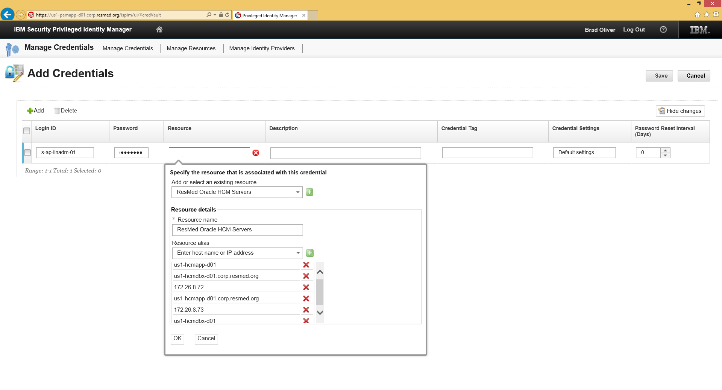

Figure 20. PIM Manage Credentials – Add Credentials Menu

1. Leave the other settings unchanged and click **OK**.

For example:

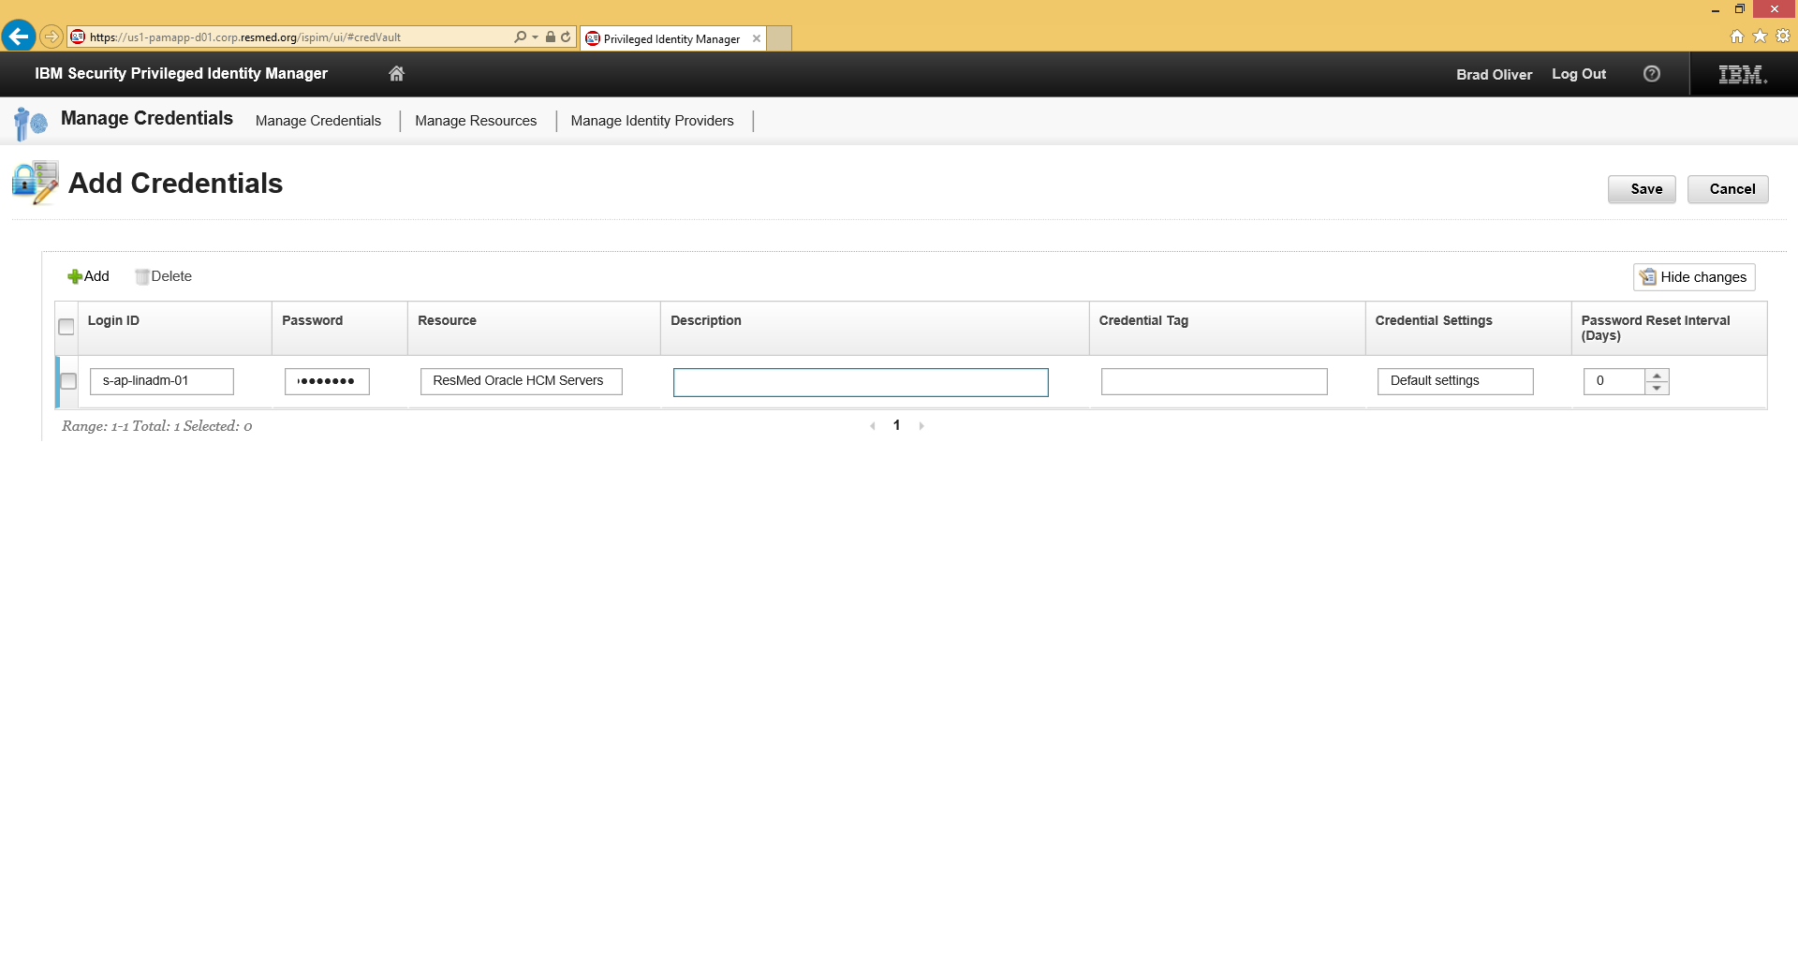

Figure 21. PIM Manage Credentials - Add Credentials Fields Input

The Manage Credentials page returns showing the new credential listed.

For example:

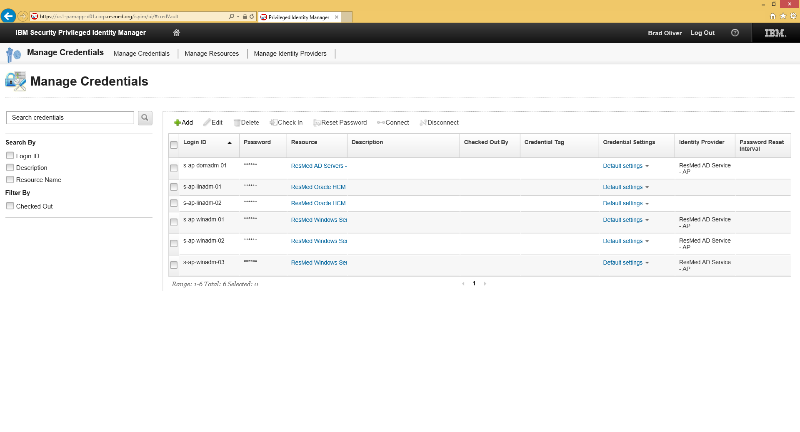

Figure 22. PIM Manage Credentials - New Credential Listed

### Edit Credentials

To edit credentials:

1. Launch a browser and specify the following URL:

**Error! Hyperlink reference not valid.**

1. Enter the Administration credentials for the domain and click **Log In**.

See .

1. On the Home page, click the **Manage Credentials** option.

See .

1. When the Manage Credentials page appears, select the credential and click **Edit**.

For example:

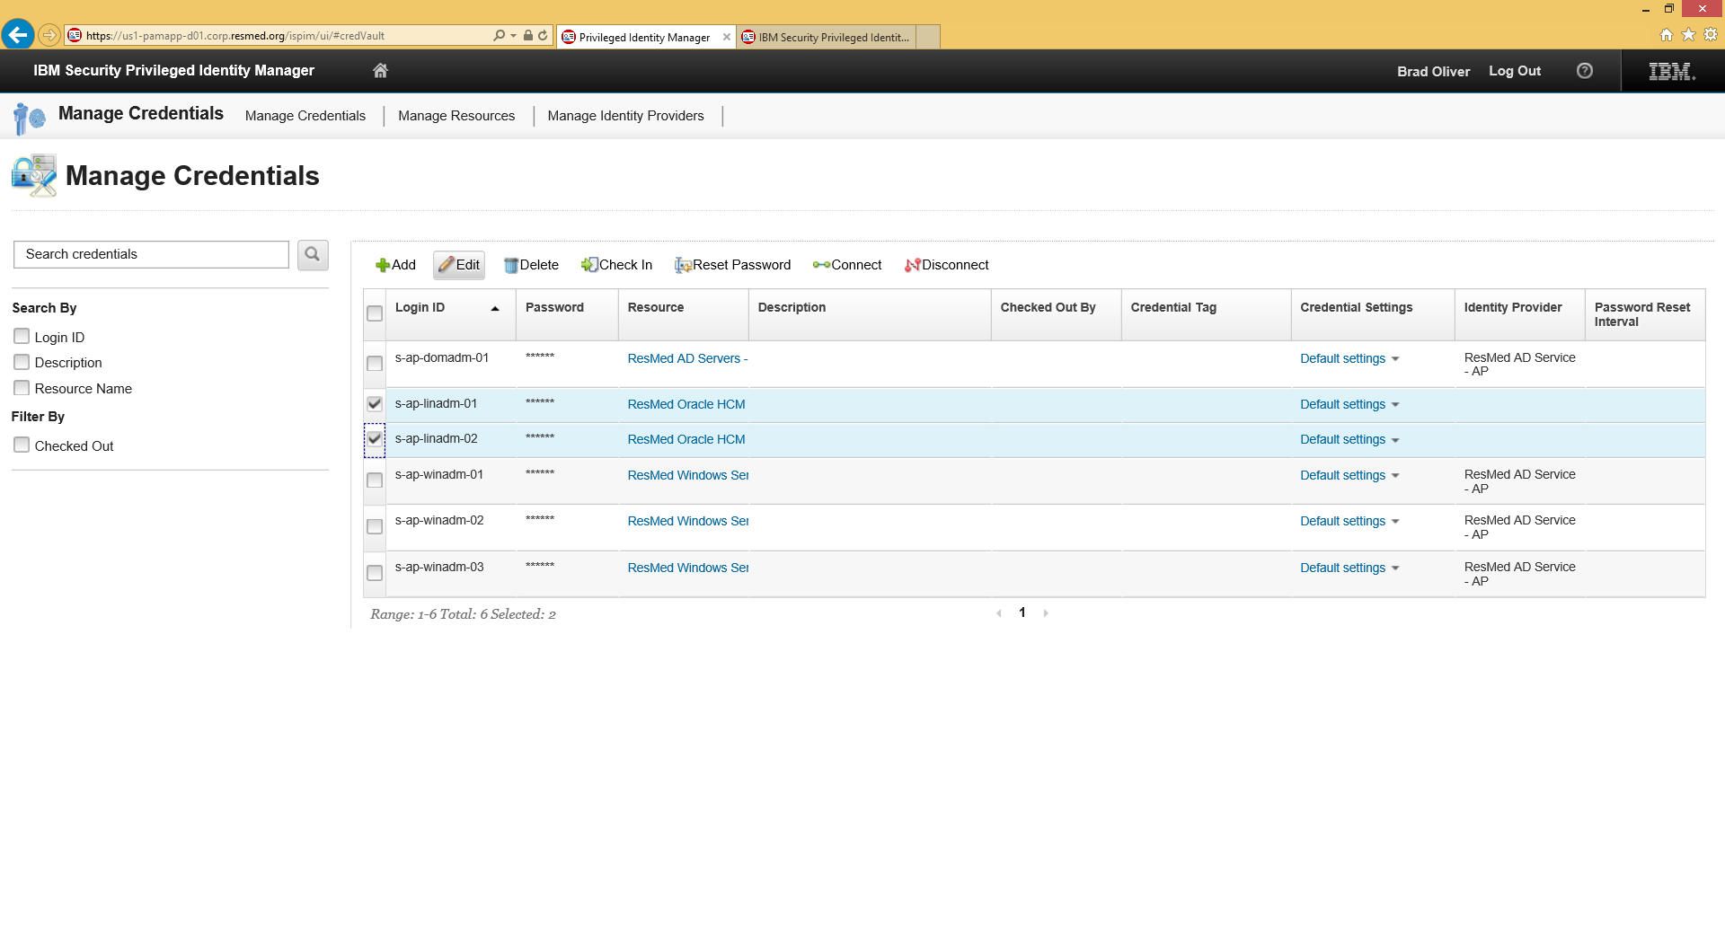

Figure 23. PIM Manage Credentials - Edit

1. Enter the changes and click **Save**.

For example:

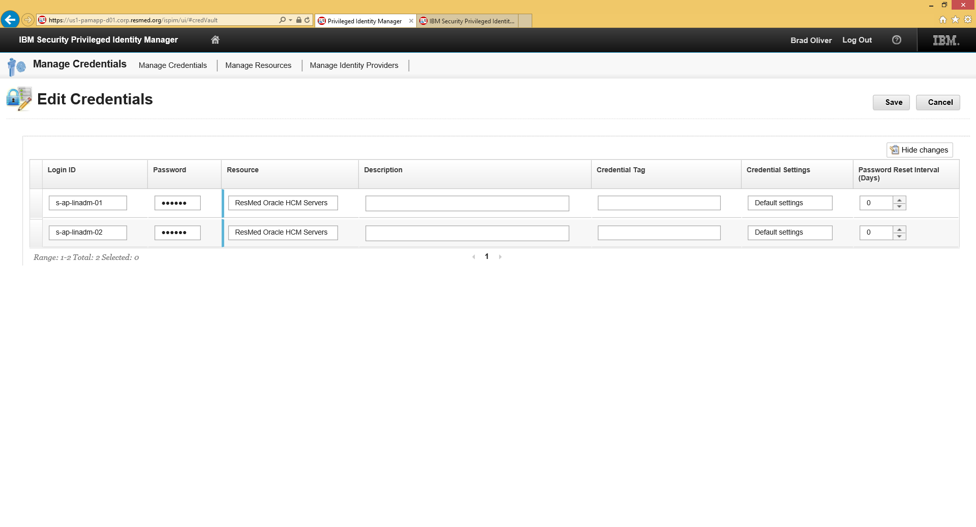

Figure 24. PIM Manage Credentials - Edit Saved

### Associate Credentials to Identity Providers

Managing passwords, Administrators associate credentials with Identity Providers such as AD, Windows, or Linux.

To associate credentials to an Identity Provider:

1. Launch a browser and specify the following URL:

**Error! Hyperlink reference not valid.**

1. Enter the Administration credentials for the domain and click **Log In**.

See .

1. On the Home page, click the **Manage Credentials** option.

See .

1. When the Manage Credentials page appears, select one or more credentials and click **Connect**.

For example:

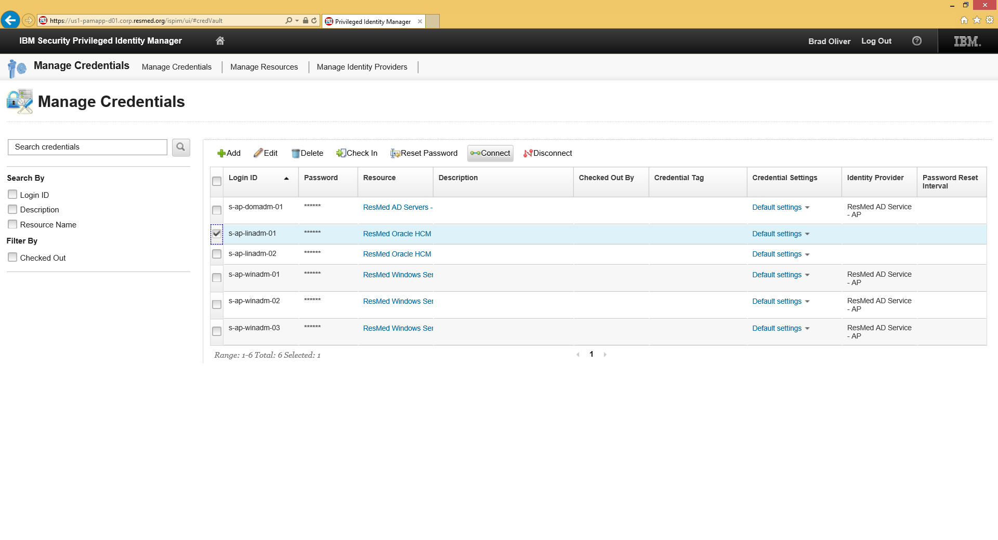

Figure 25. PIM Manage Credentials - Connect

1. On the next page, select the appropriate Identity Provider from the drop-down menu.

If the user account is in an AD, select the AD Identity Provider. If the credential is local to a Linux server, select the Identity Provider created for Linux

For example:

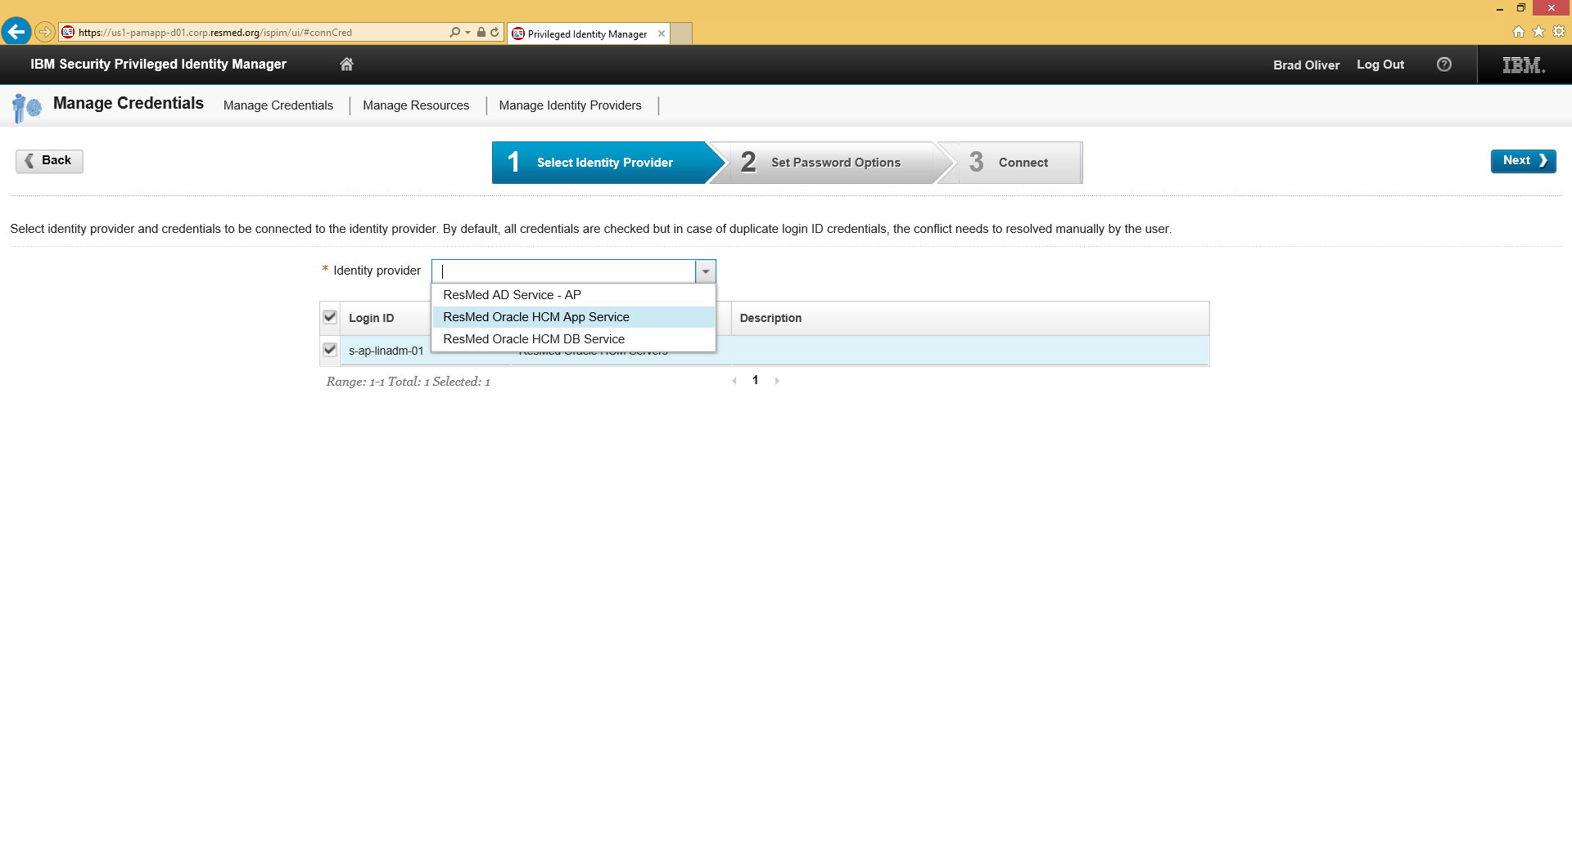

Figure 26. PIM Manage Credentials - Selecting Identity Provider

The page shows the selected Identity Provider.

For example:

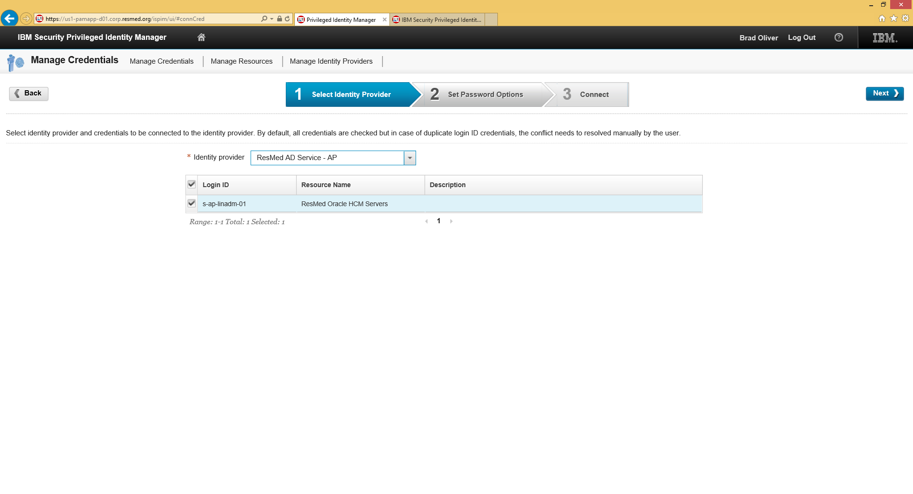

Figure 27. PIM Manage Credentials – Identity Provider Selected

1. Click **Next**.
2. When the page shows the Identity Provider selection, verify the information and click **Connect**.

For example:

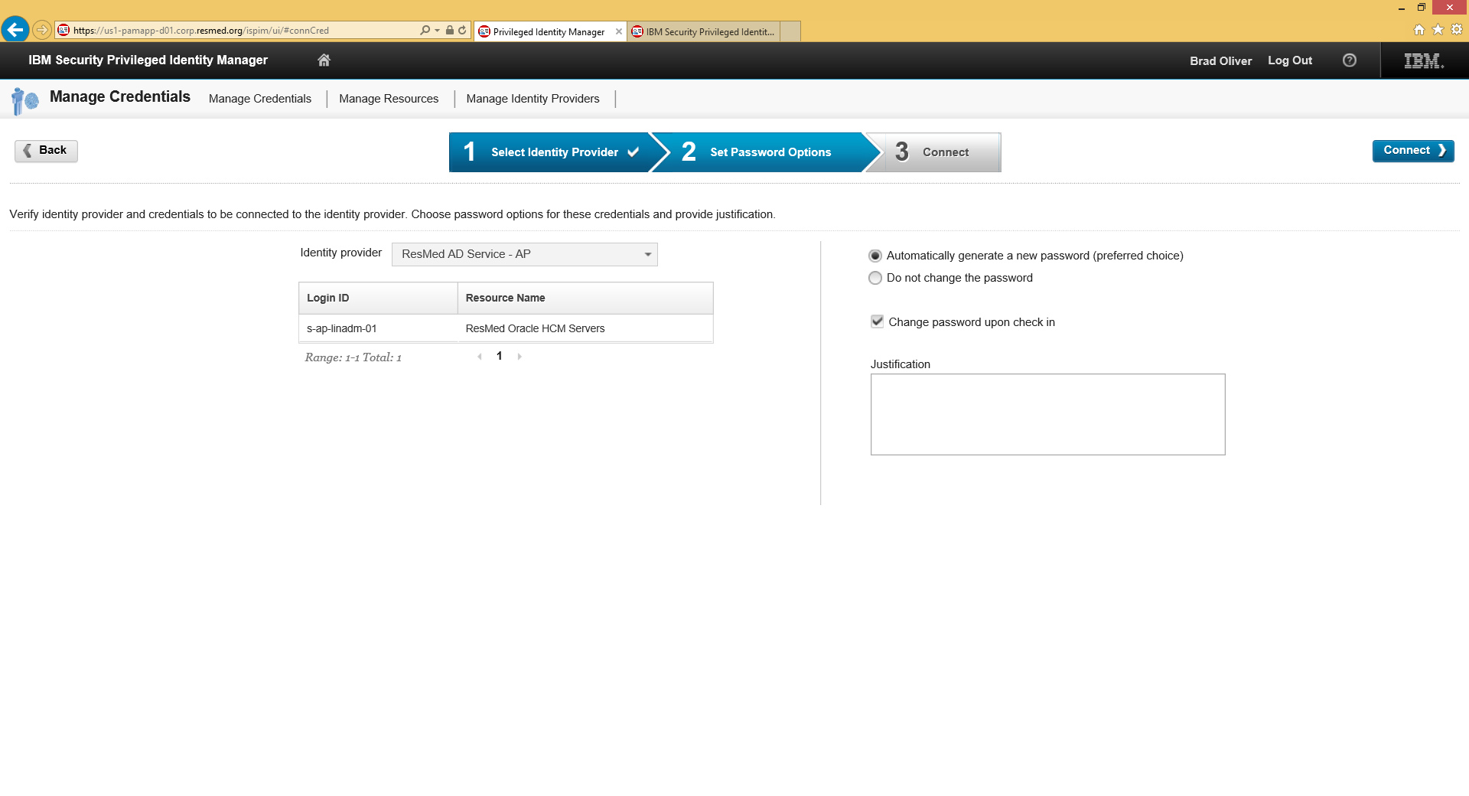

Figure 28. PIM Manage Credentials - Identity Provider Connect

On the next page, a success message appears at the top.

For example:

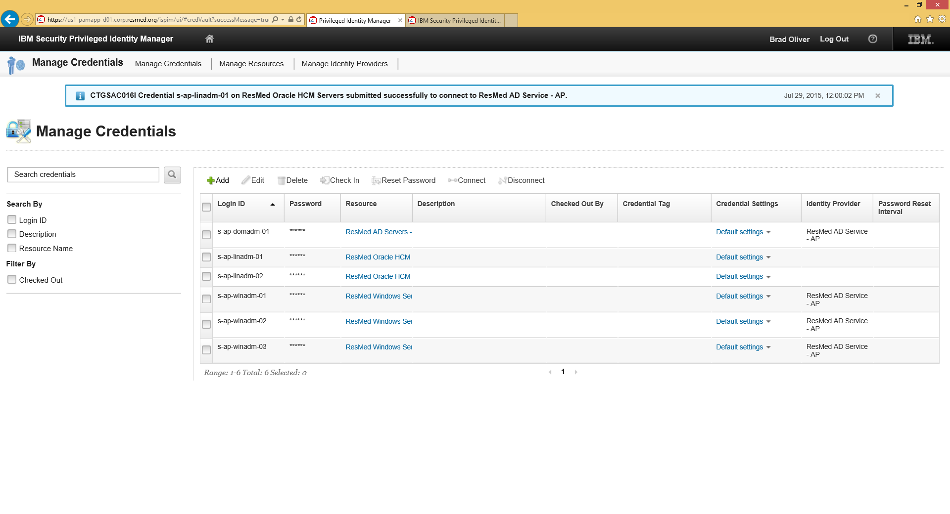

Figure 29. PIM Manage Credentials - Connect Verified

1. Refresh the page and view it to verify the presence of the Identity Provider name in the list.

For example:

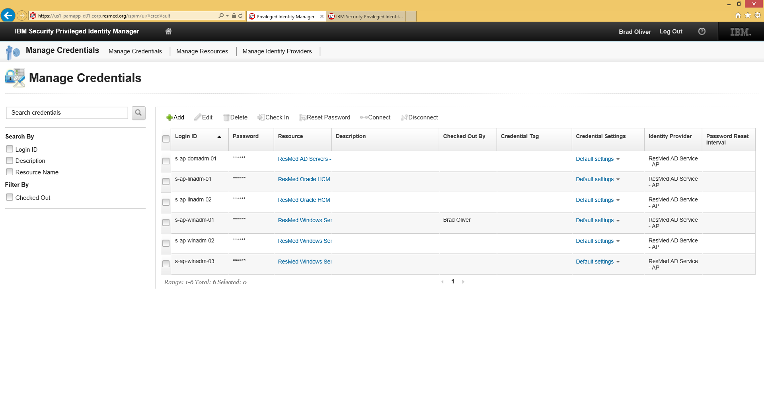

Figure 30. PIM Manage Credentials - Final Verification

### Check In Credentials

If credentials are checked out by an Administrator but are not checked in later, the PIM user’s name will remain in the “Checked out by” column. An Administrator can check credential back in using the PIM console.

To check in credentials:

1. Launch a browser and specify the following URL:

**Error! Hyperlink reference not valid.**

1. Enter the Administration credentials for the domain and click **Log In**.

See .

1. On the Home page, click the **Manage Credentials** option.

See

1. Select the credential on the Manage Credentials page and click **Check In**.

For example:

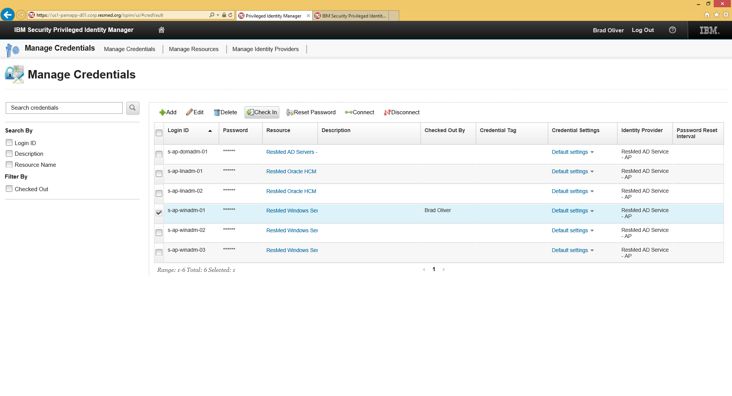

Figure 31. PIM Manage Credentials - Check In

1. When the Confirmation prompt appears, click **Yes**.

For example:

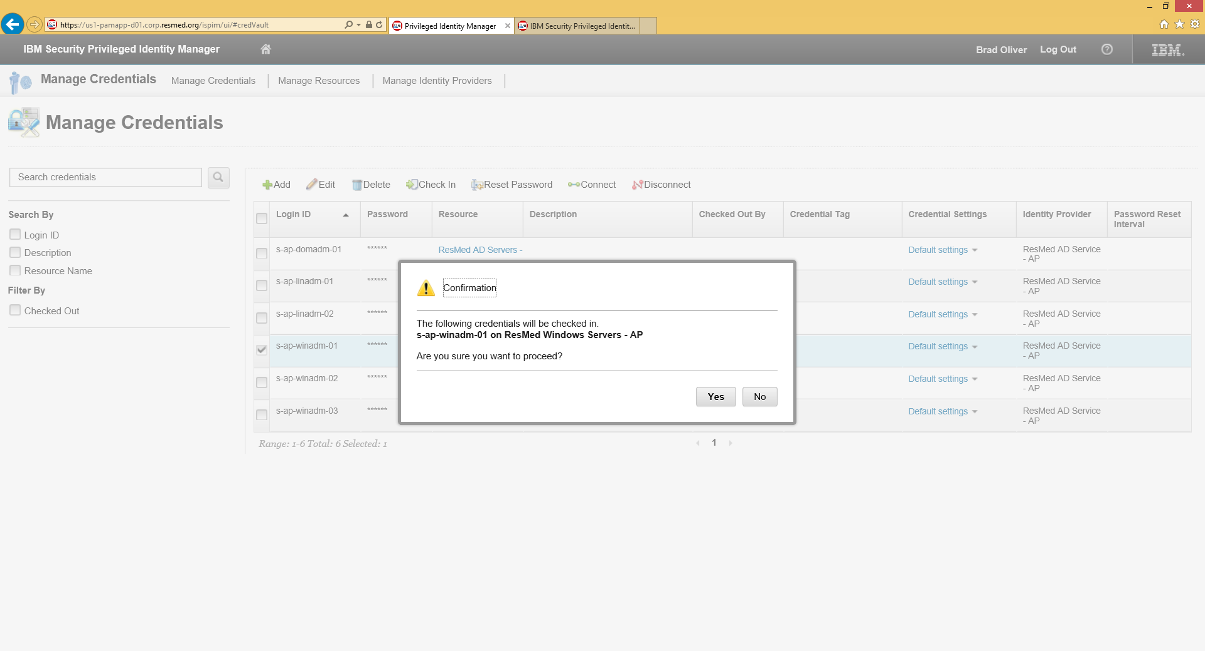

Figure 32. PIM Credentials - Confirm Check In

1. View the Manage Credentials page to verify that the item is cleared from Checked Out column.

For example:

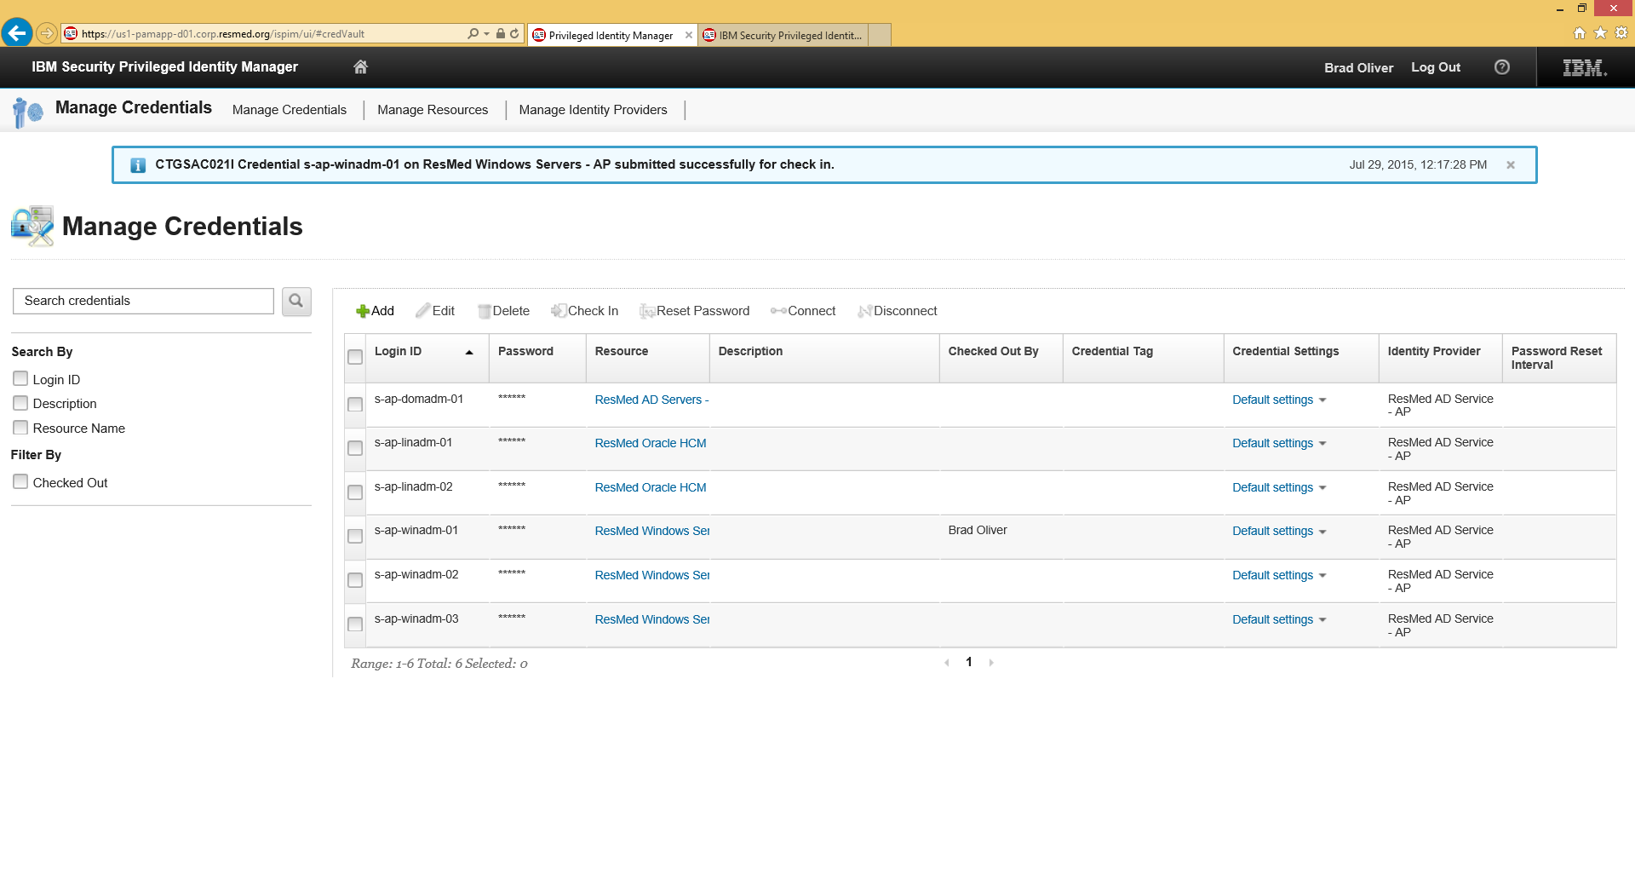

Figure 33. PIM Manage Credentials - Check In Verified

### Reset Passwords

To reset a password:

1. Launch a browser and specify the following URL:

**Error! Hyperlink reference not valid.**

1. Enter the Administration credentials for the domain and click **Log In**.

See .

1. On the Home page, click the **Manage Credentials** option.

See .

1. Select the password on the Manage Credentials page and click **Reset Password**.

For example:

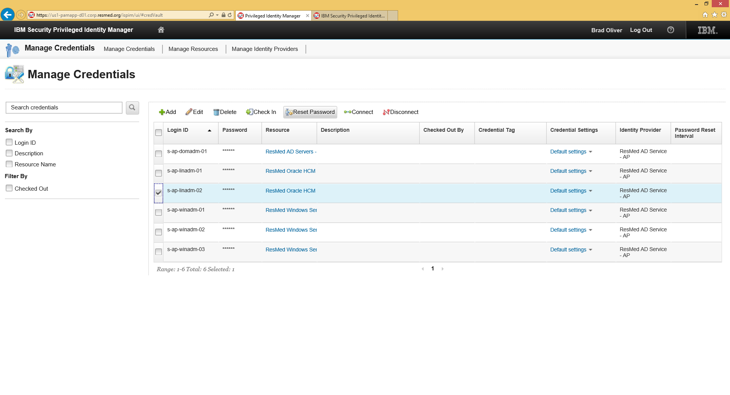

Figure 34. PIM Manage Credentials - Reset Password

1. When the Confirmation prompt appears, click **Yes**.

For example:

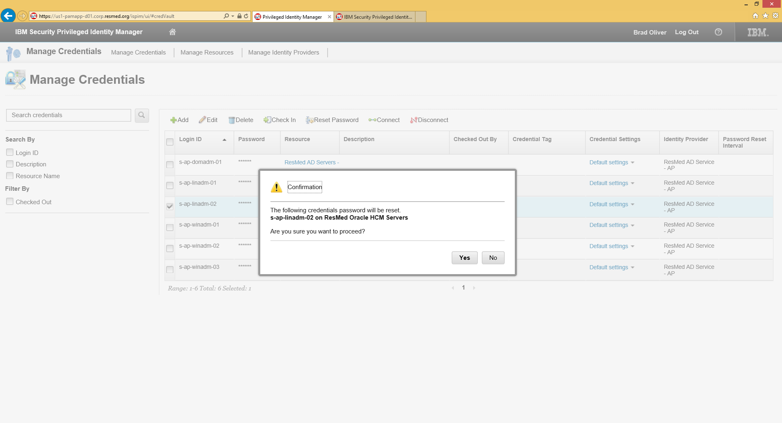

Figure 35. Manage Credentials – Confirm Reset

The reset request is submitted for the selected credentials.

For example:

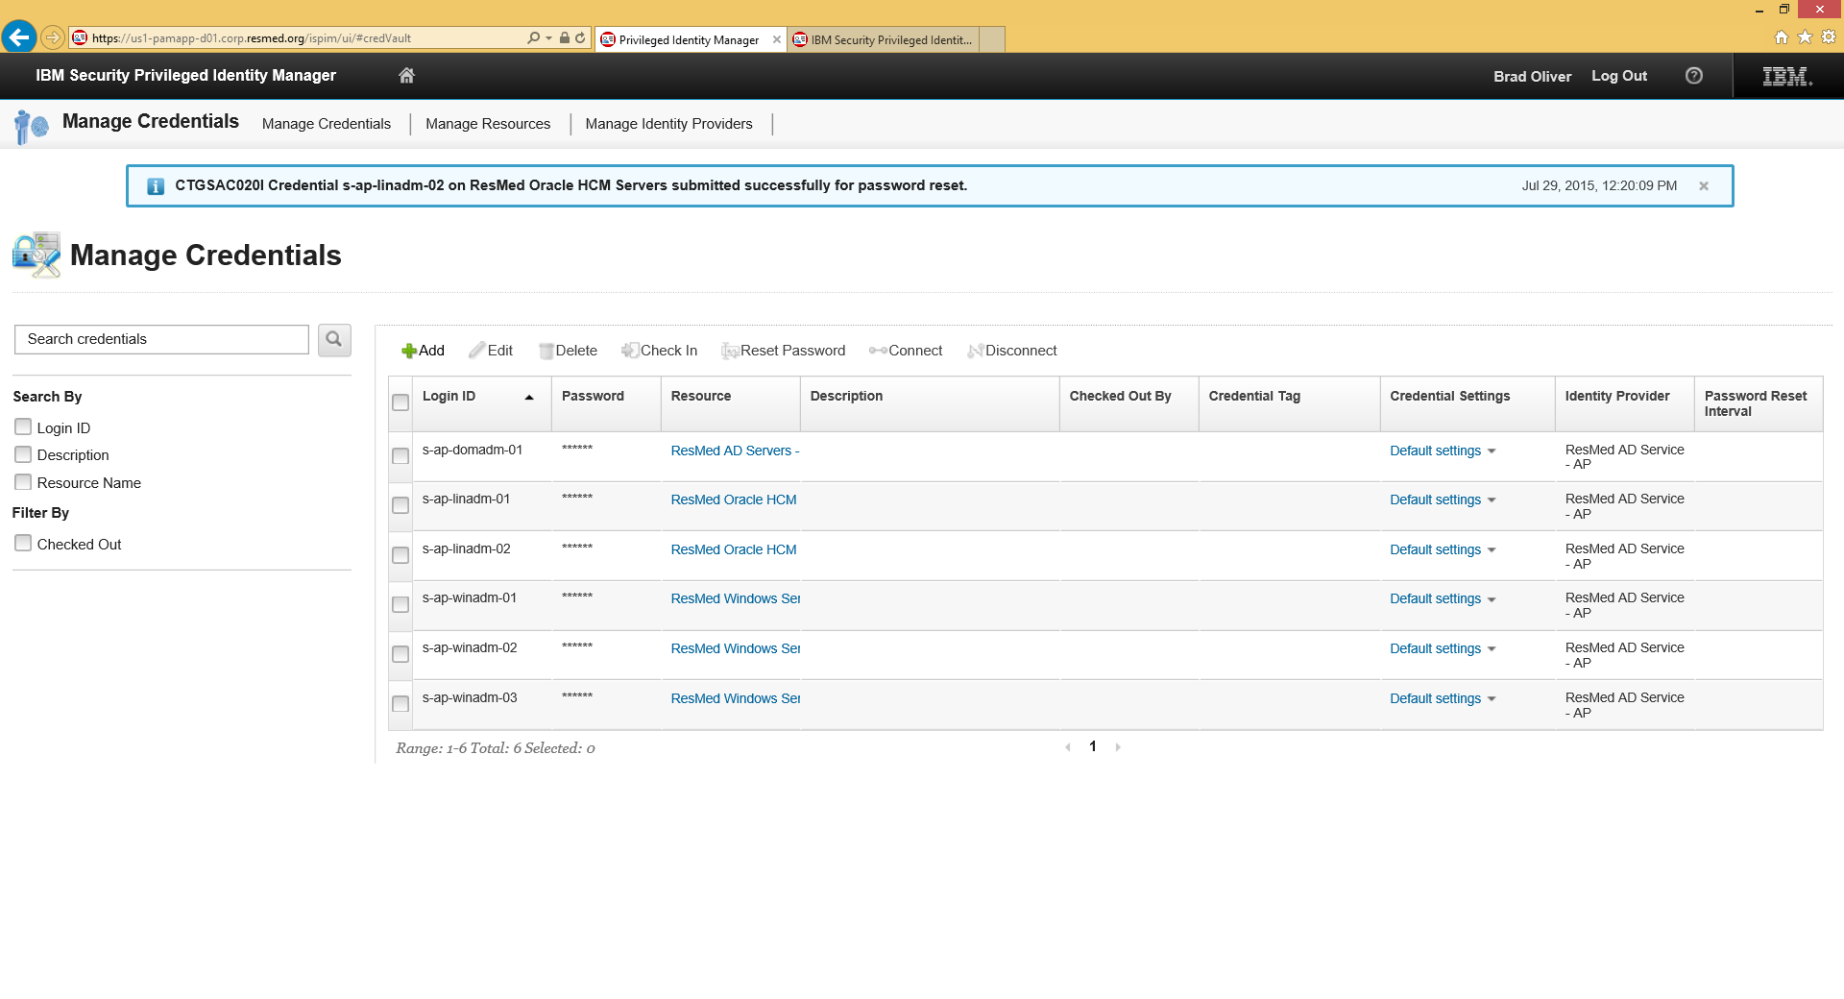

Figure 36. PIM Manage Credentials - Reset Submitted

1. Optionally, to verify the password reset, view the logs on the PIM Administration console.

For example:

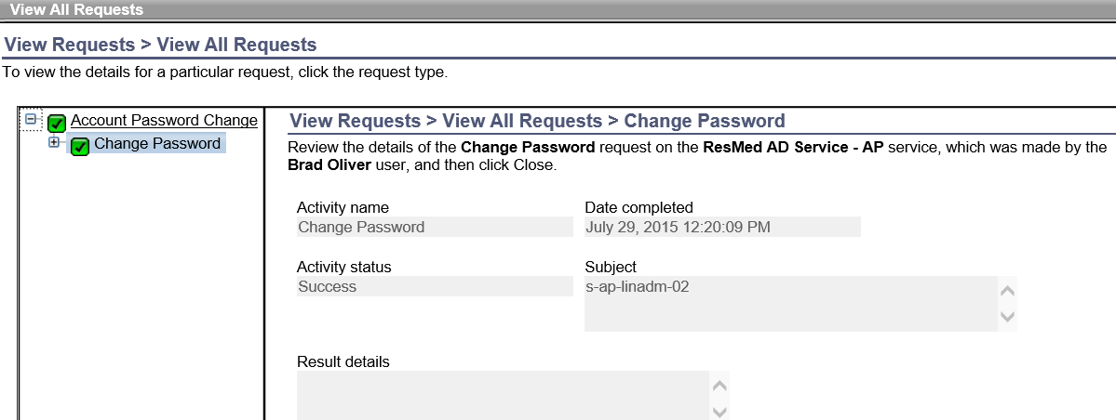

Figure 37. PIM Manage Credentials - View Log

## Managing Access

An Administrator can grant access to resources. This section explains how to create an access policy, edit a policy, and delete a policy.

### Create a New Access Policy

To create a new access policy:

1. Launch a browser and specify the following URL:

**Error! Hyperlink reference not valid.**

1. Enter the Administration credentials for the domain and click **Log In**.

See .

1. On the Home page, click the **Manage Access** option.

See .

1. When the Manage Access page appears, click **Add**.

For example:

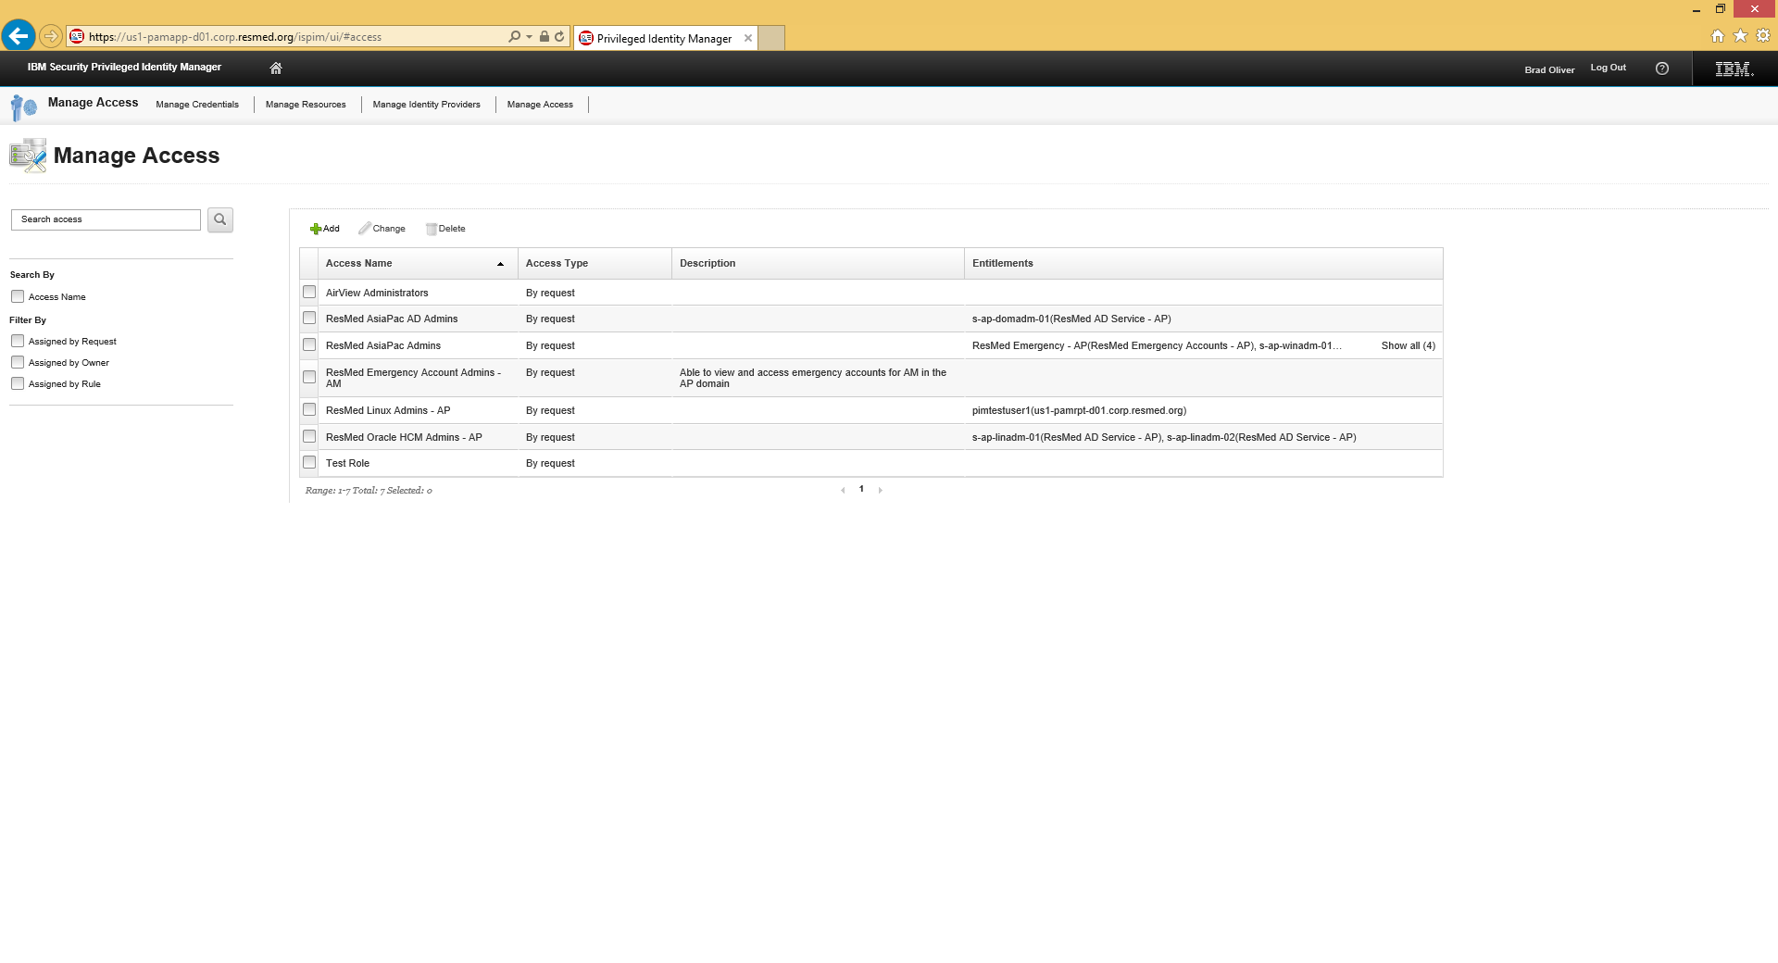

Figure 38. PIM Manage Access – Add Policy

1. Enter a name for the policy.
2. Under Assignment Type, select **By Request** and then, click **Next**.

For example

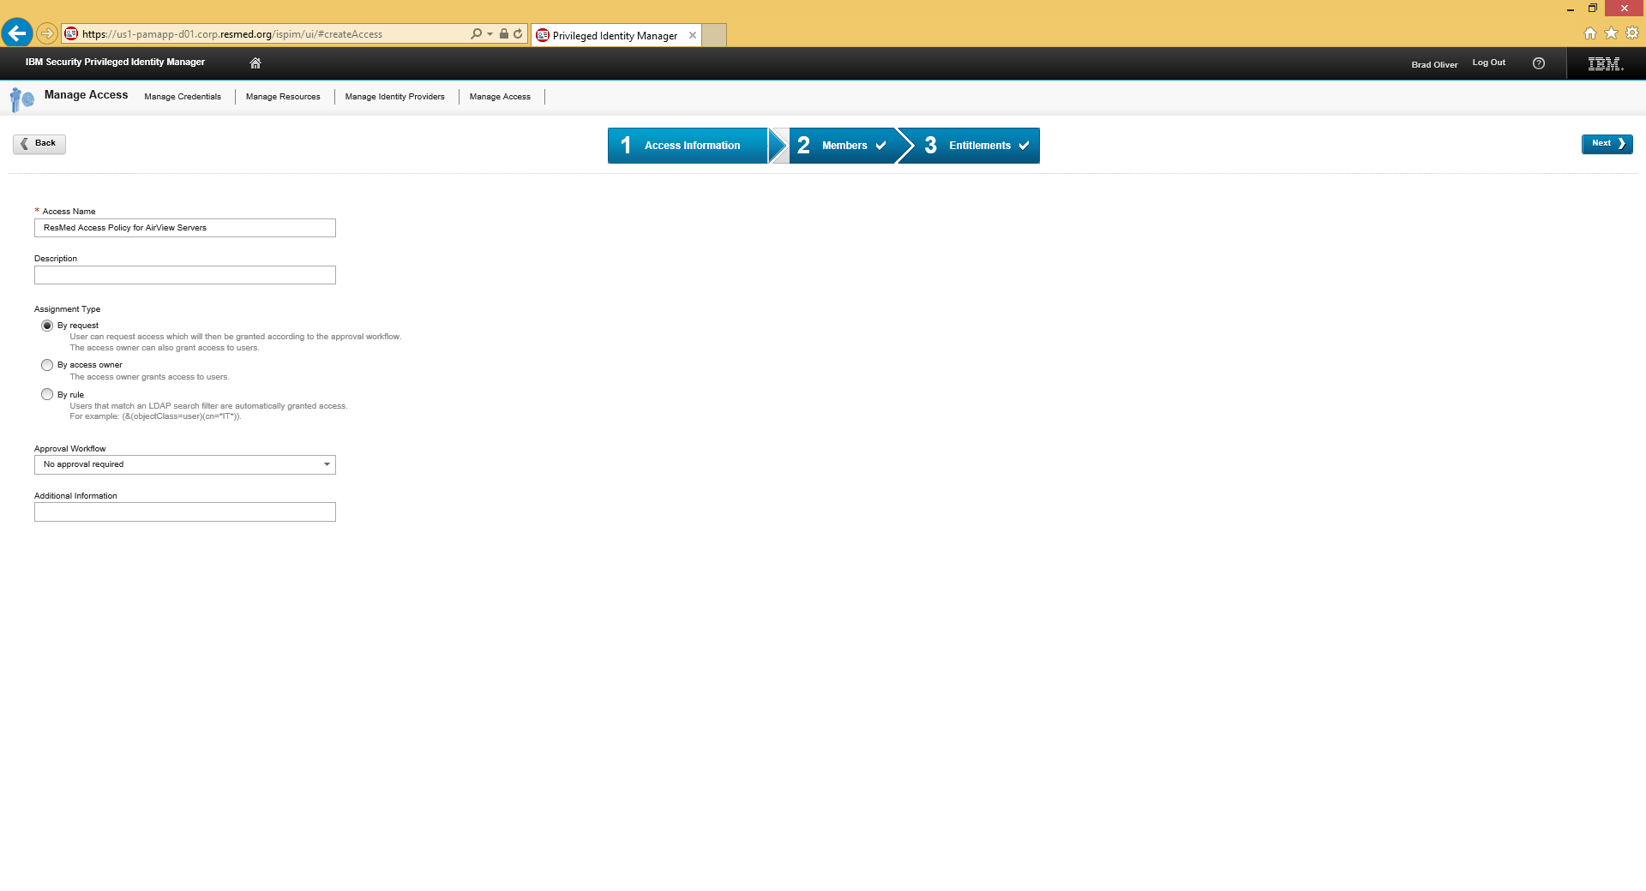

Figure 39. PIM Manage Access - Name Policy

1. Under the Members tab, select users in the Available Users column and move them to the Selected Users list by clicking **Add>** and then, click **Next.**

For example:

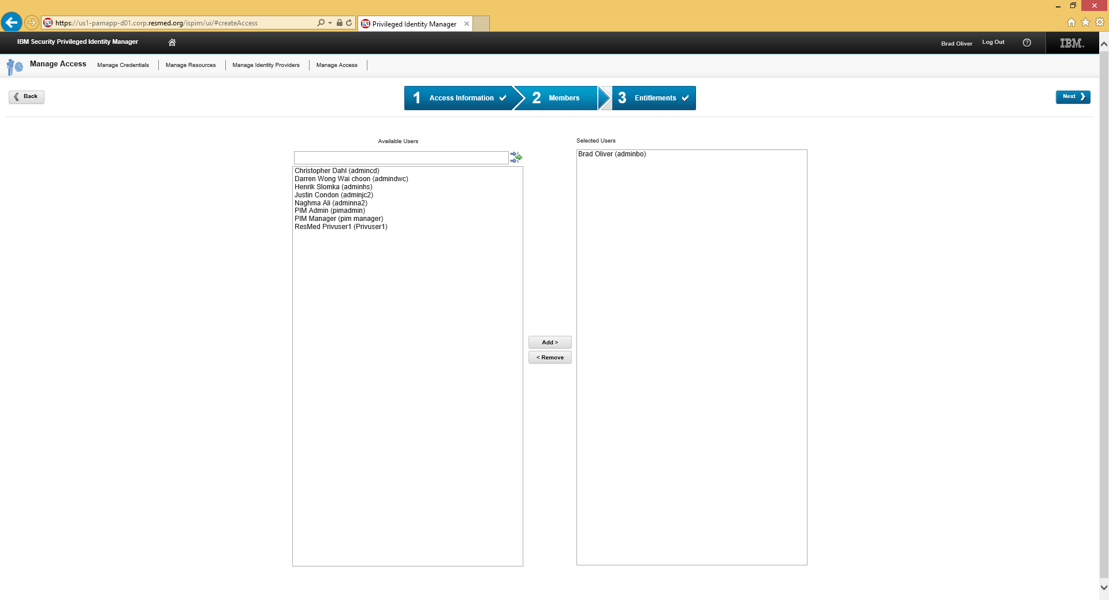

Figure 40. PIM Manage Access - Add Users

The next page appears, listing Entitlements by type (Credential, Credential Pool, Filter).

For each type, the page shows resources per login ID. For example:

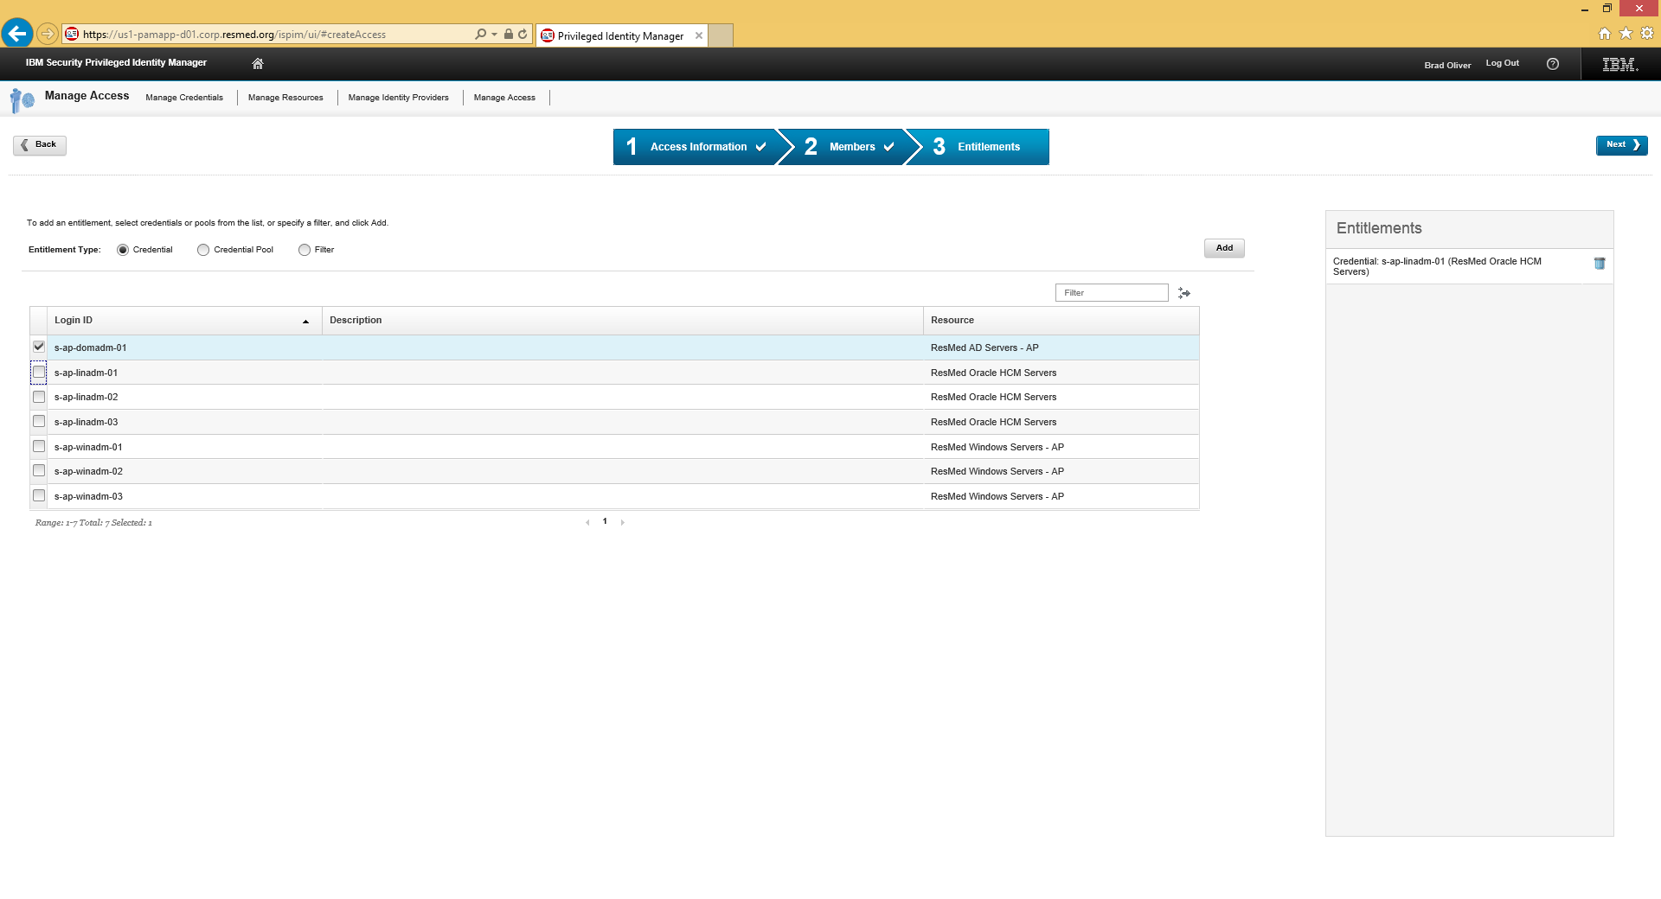

Figure 41. PIM Manage Access – Entitlements Listed by Type

1. Select one or more Entitlements (credentials or credential pool) that will be used to connect to a resource click **Add** and then, click **Next**.

The Manage Access main page appears showing the newly created Access Policy.

For example:

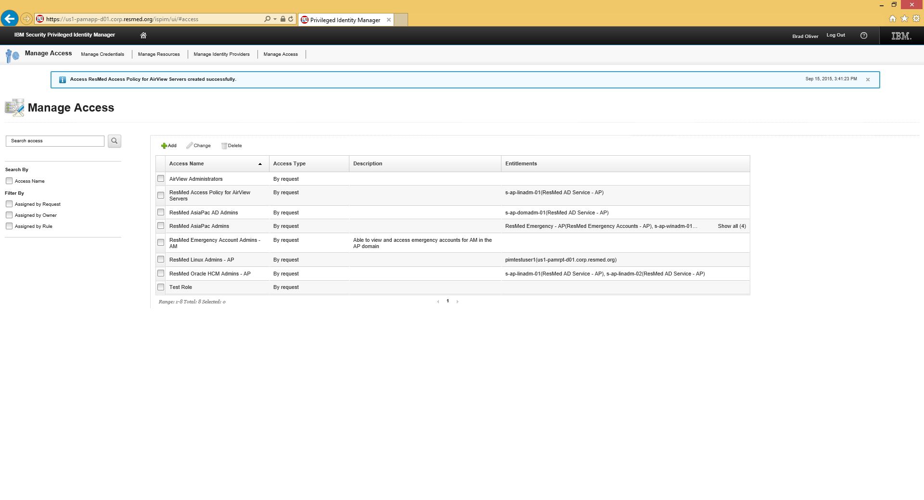

Figure 42. PIM Manage Access - New Access Policy Listed

### Edit a Policy

To edit a policy:

1. Launch a browser and specify the following URL:

**Error! Hyperlink reference not valid.**

1. Enter the Administration credentials for the domain and click **Log In**.

See .

1. On the Home page, click the **Manage Access** option.

See .

1. On the Manage Access page listing policies, select the policy and then, click **Change**.

For example:

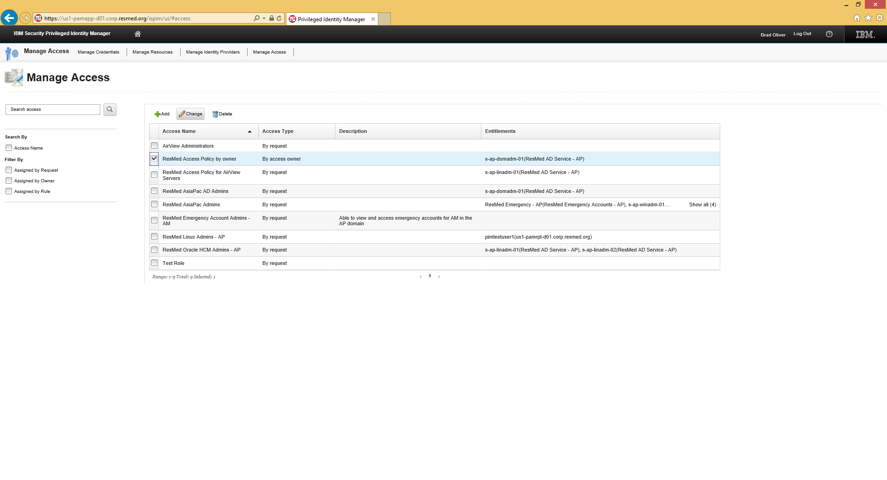

Figure 43. Manage Access – Edit Policy

1. Change the Members or Entitlements by clicking on the appropriate section and then, click **Submit**.

**Note**: The policy Assignment Type cannot be changed.

For example:

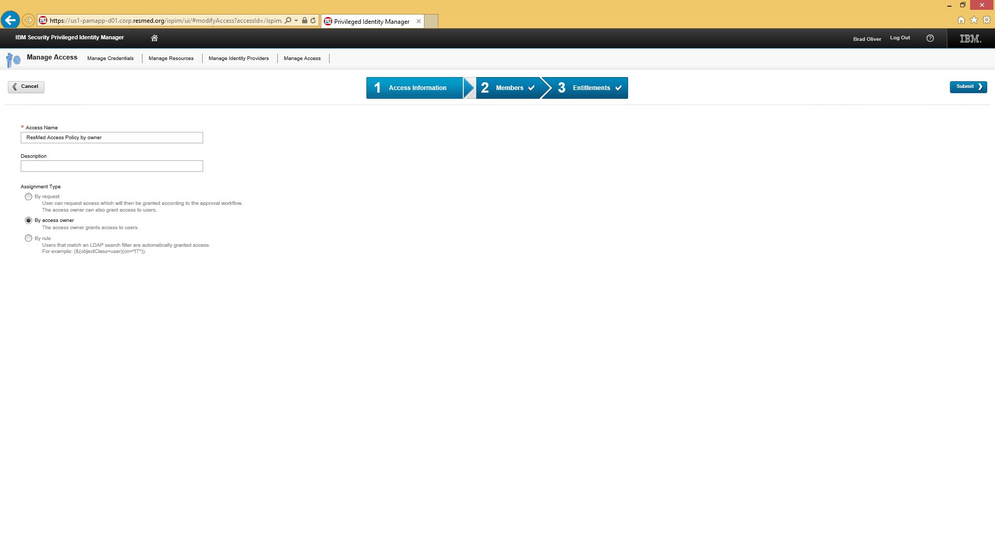

Figure 44. PIM Manage Access – Policy Edited

### Delete a Policy

To delete a policy:

1. Launch a browser and specify the following URL:

**Error! Hyperlink reference not valid.**

1. Enter the Administration credentials for the domain and click **Log In**.

See .

1. On the Home page, click the **Manage Access** option.

See .

1. On the Manage Access page listing policies, select the policy and then, click **Delete**.

For example:

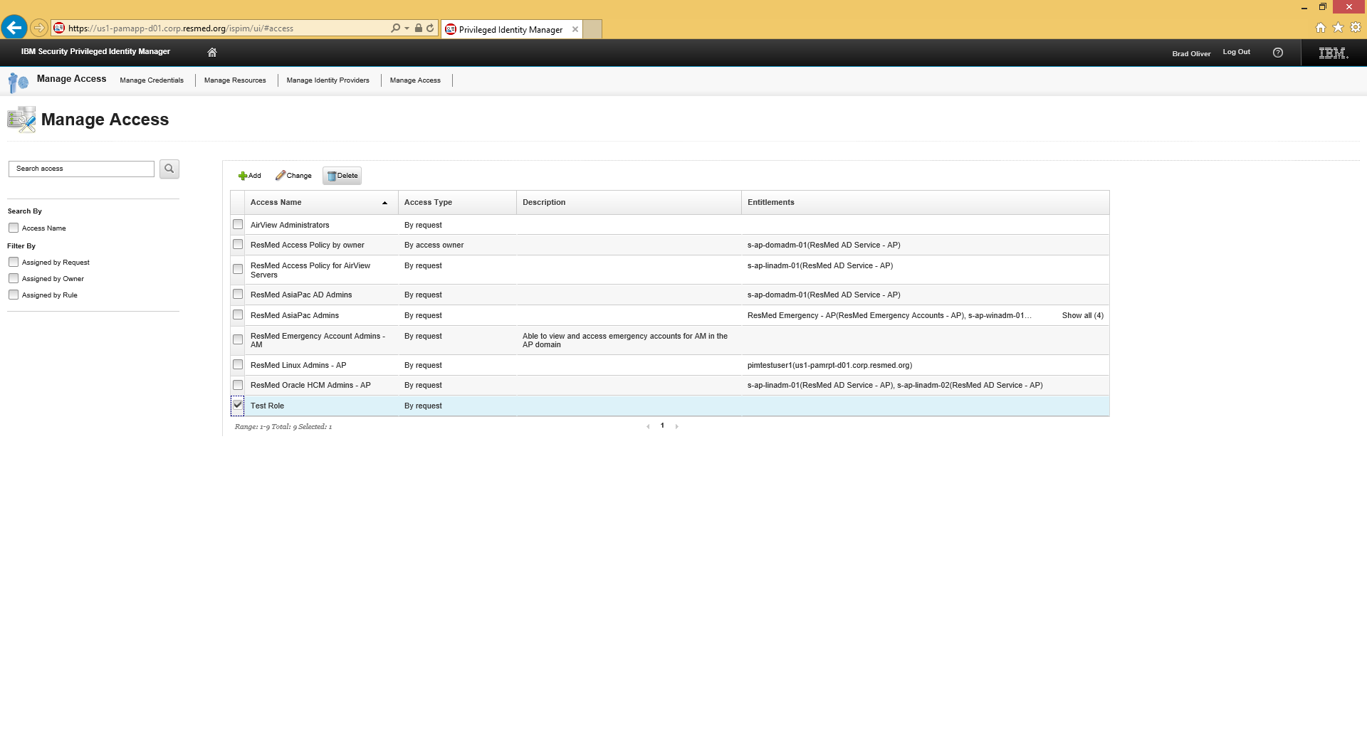

Figure 45. PIM Manage Access - Delete Policy

1. When you are promoted to confirm the deletion, click **Yes**.

For example:

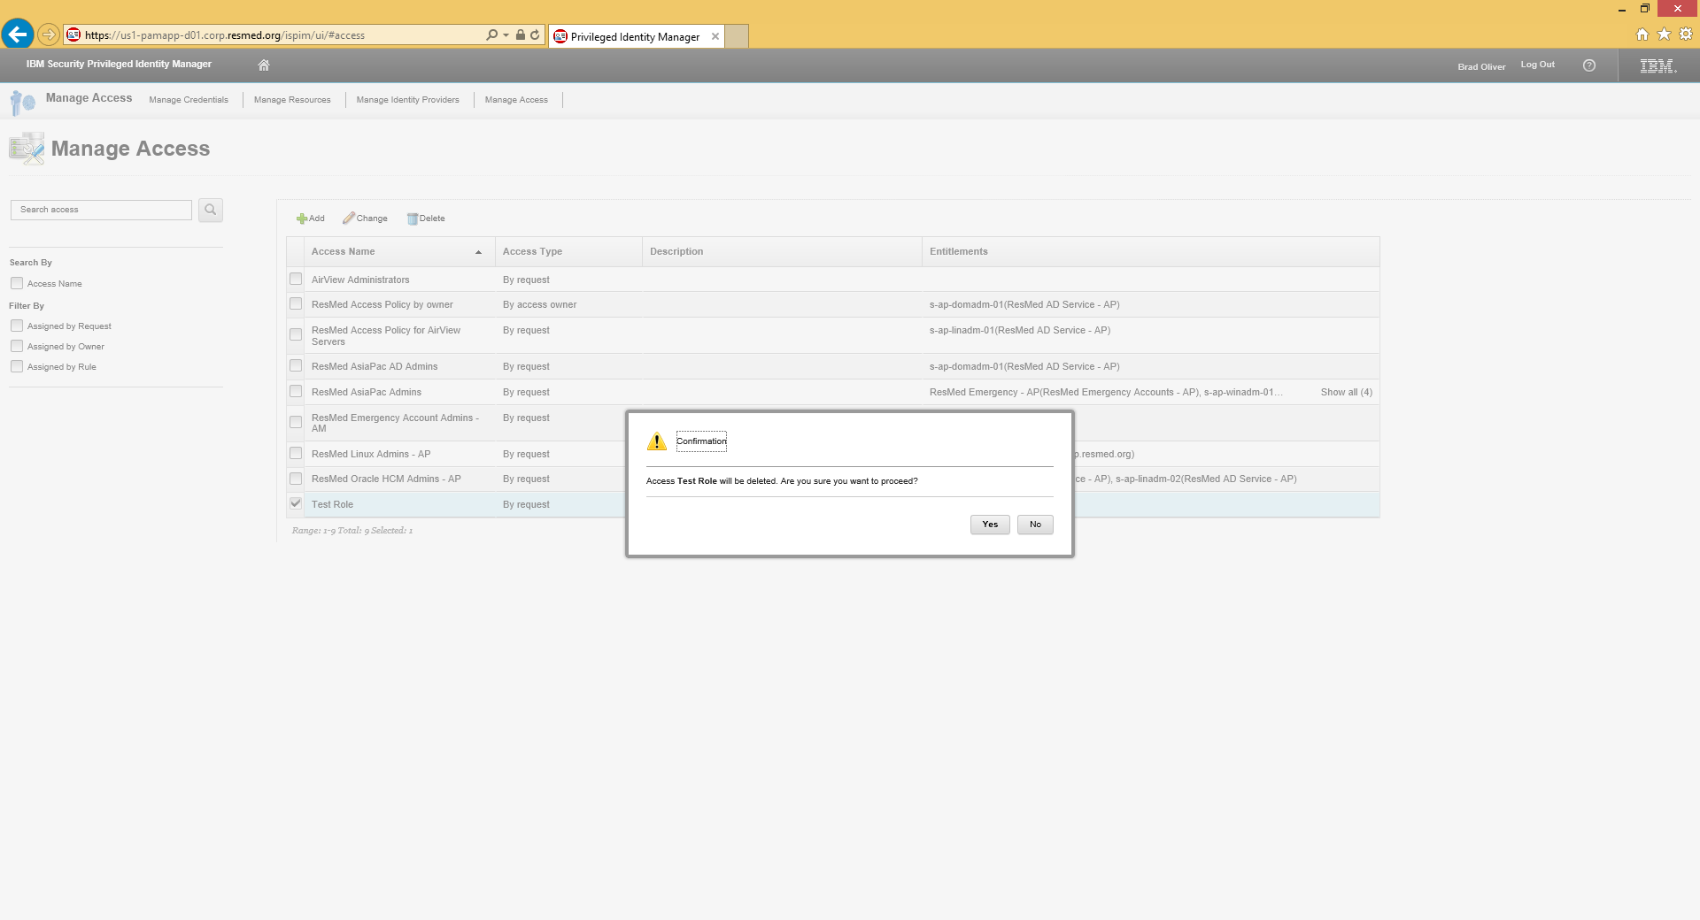

Figure 46. PIM Manage Access - Confirm Deletion

# PIM ADMINISTRATIVE CONSOLE TASKS

An Administrator can use the Administrative Console to perform various tasks, depending upon their membership within PIM groups. These tasks include logging in and managing the Credential Vault, Shared Access Policies, Requests, and Users and User Roles.

## Log In

To login:

1. Launch the browser and go to URL:

**Error! Hyperlink reference not valid.**.

1. When the IBM Security Privileged Identity Manager home page appears, enter your User ID and Password. For example:

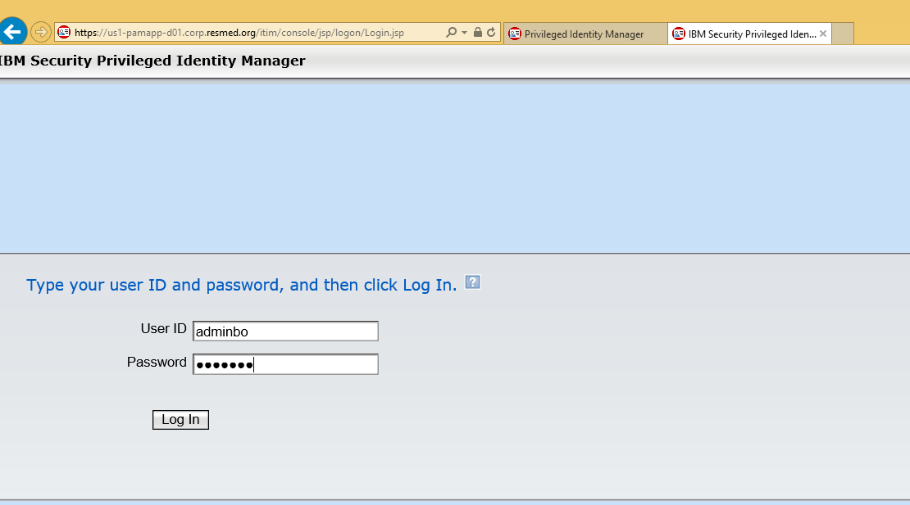

Figure 47. PIM Administrator Console Log In

After logging in, an Administrator can access the options shown below.

**Note**: Group membership determines the exact options list.

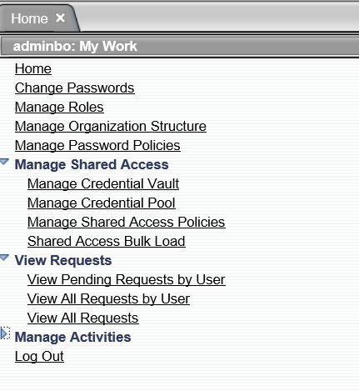

Figure 48. PIM Administrator Console Options

## Managing Credential Vault

The Credential Vault is a repository for all individual and shared credentials. New credentials are added via the PIM Administrator Console or the PIM Manage Credentials feature. This section focuses on the Console.

### Add New Credentials

To add new credentials to the vault:

1. Login to the PIM Console.

See section 5.1 Logging In.

1. On the Console page, go to **Manage Shared Access > Manage Credential Vault** and then, click **Add**.

The Manage Shared Access > Manage Credential Vault page appears. For example:

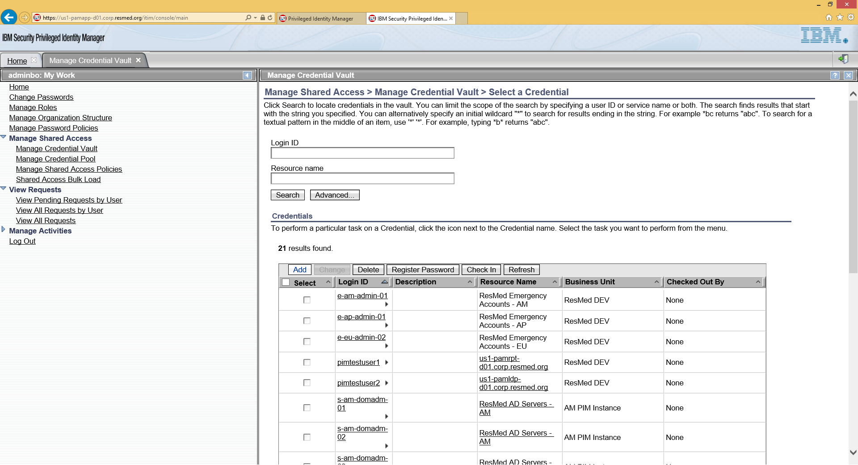

Figure 49. PIM Manage Credential Vault - Add Credential

1. Select a Shared Option or accept the default setting and then, click **Continue**.

For example:

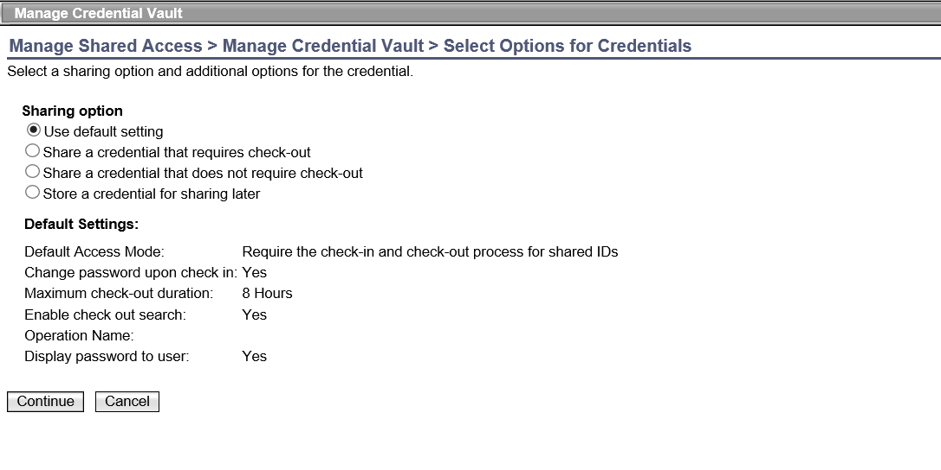

Figure 50. PIM Manage Credential Vault - Select Shared Option

1. Enter User ID, Password, and confirm the Password.

For example:

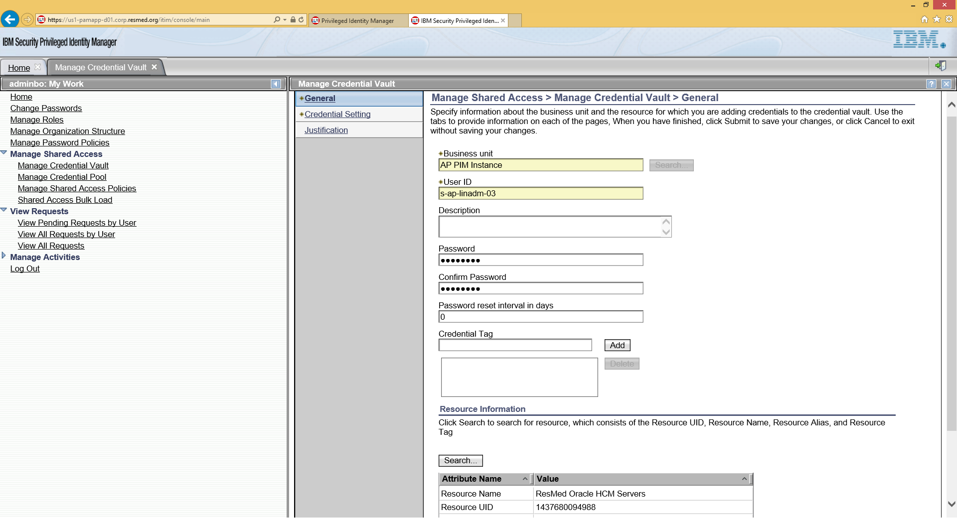

Figure 51. PIM Manage Credential Vault - User ID, Password

1. Click **Search** to add the resource that will be accessed by the new credential.

The system searches and adds the selected resource.

1. Click **Submit**.

For example:

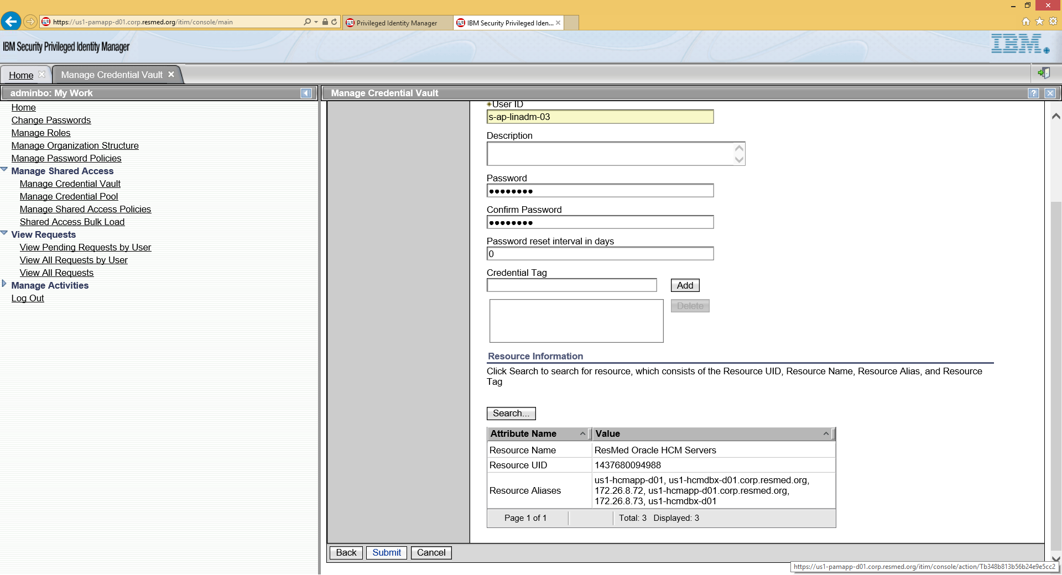

Figure 52. PIM Manage Credential Vault – New Credential Submit

1. When the Success page appears, click **Close** to exit. For example:

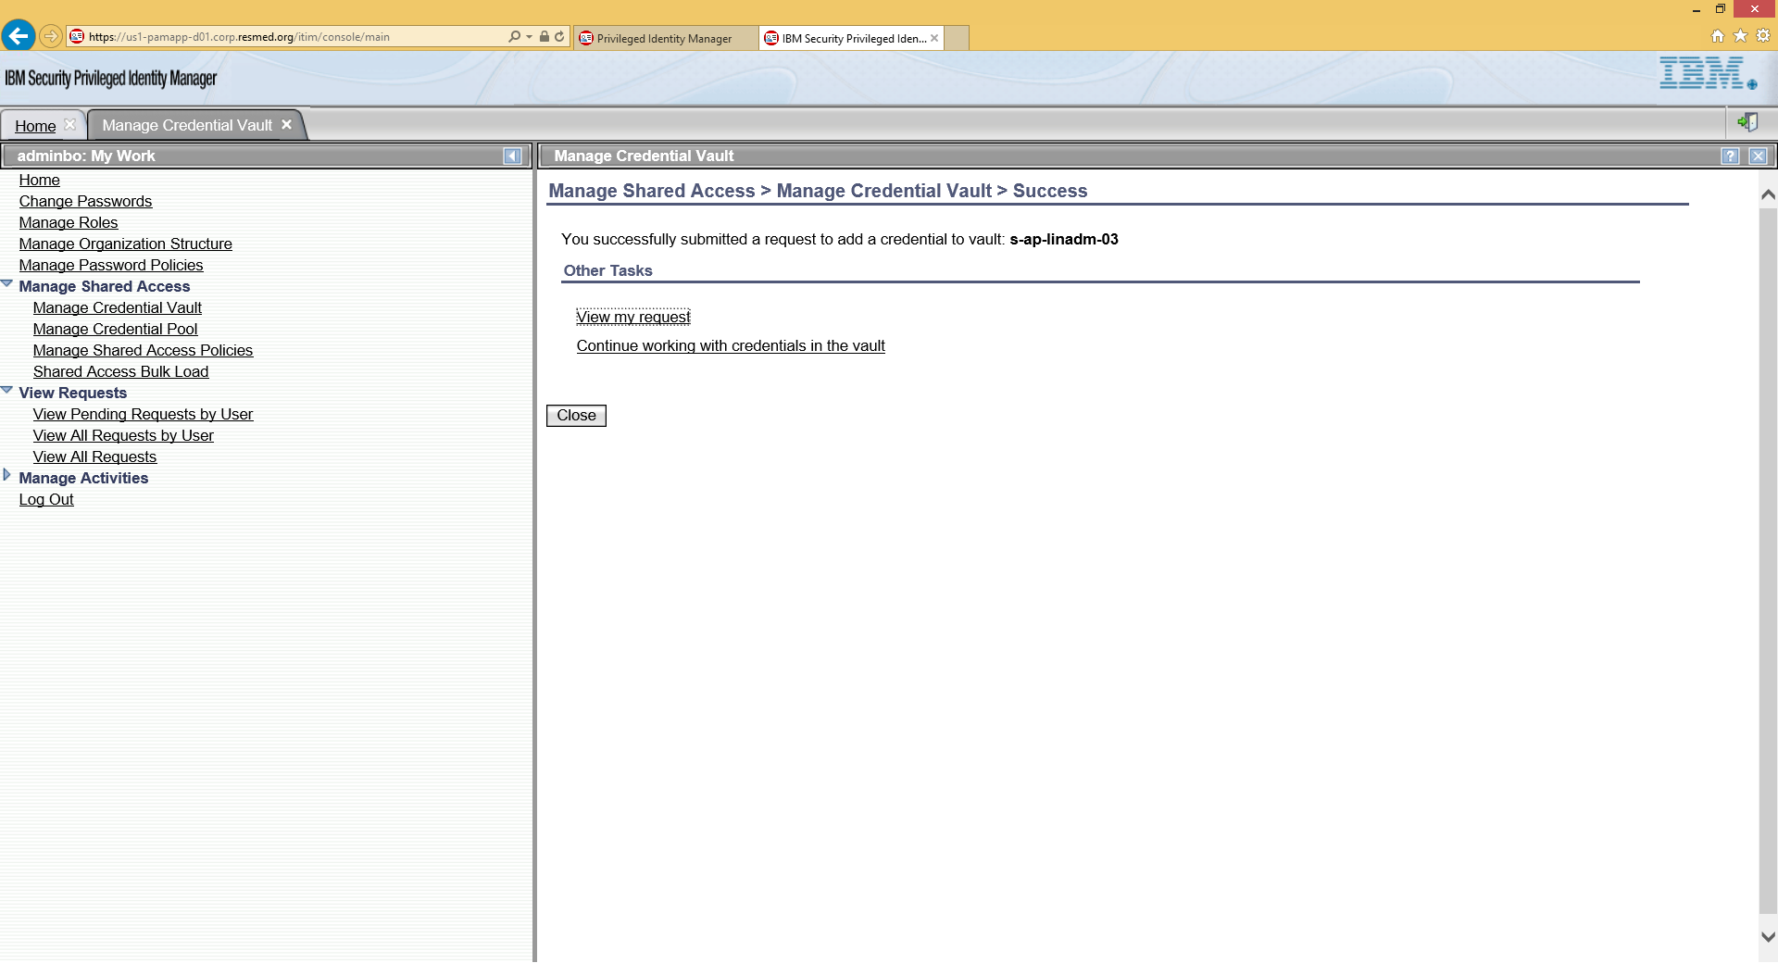

Figure 53. PIM Manage Credential Vault - Success

## Managing Credential Pools

A pool is a collection of credentials with the same access privileges. For example, credentials in the Domain Admins pool have Domain Administrator privileges to the Active Directory.

### Create a Credential Pool

An Administrator can create a new credential pool.

To create a pool:

1. Login to the PIM Console.

See section 5.1 Logging In.

1. On the Console page, select the **Manage Credential Pool** tab.

The corresponding page appears. For example:

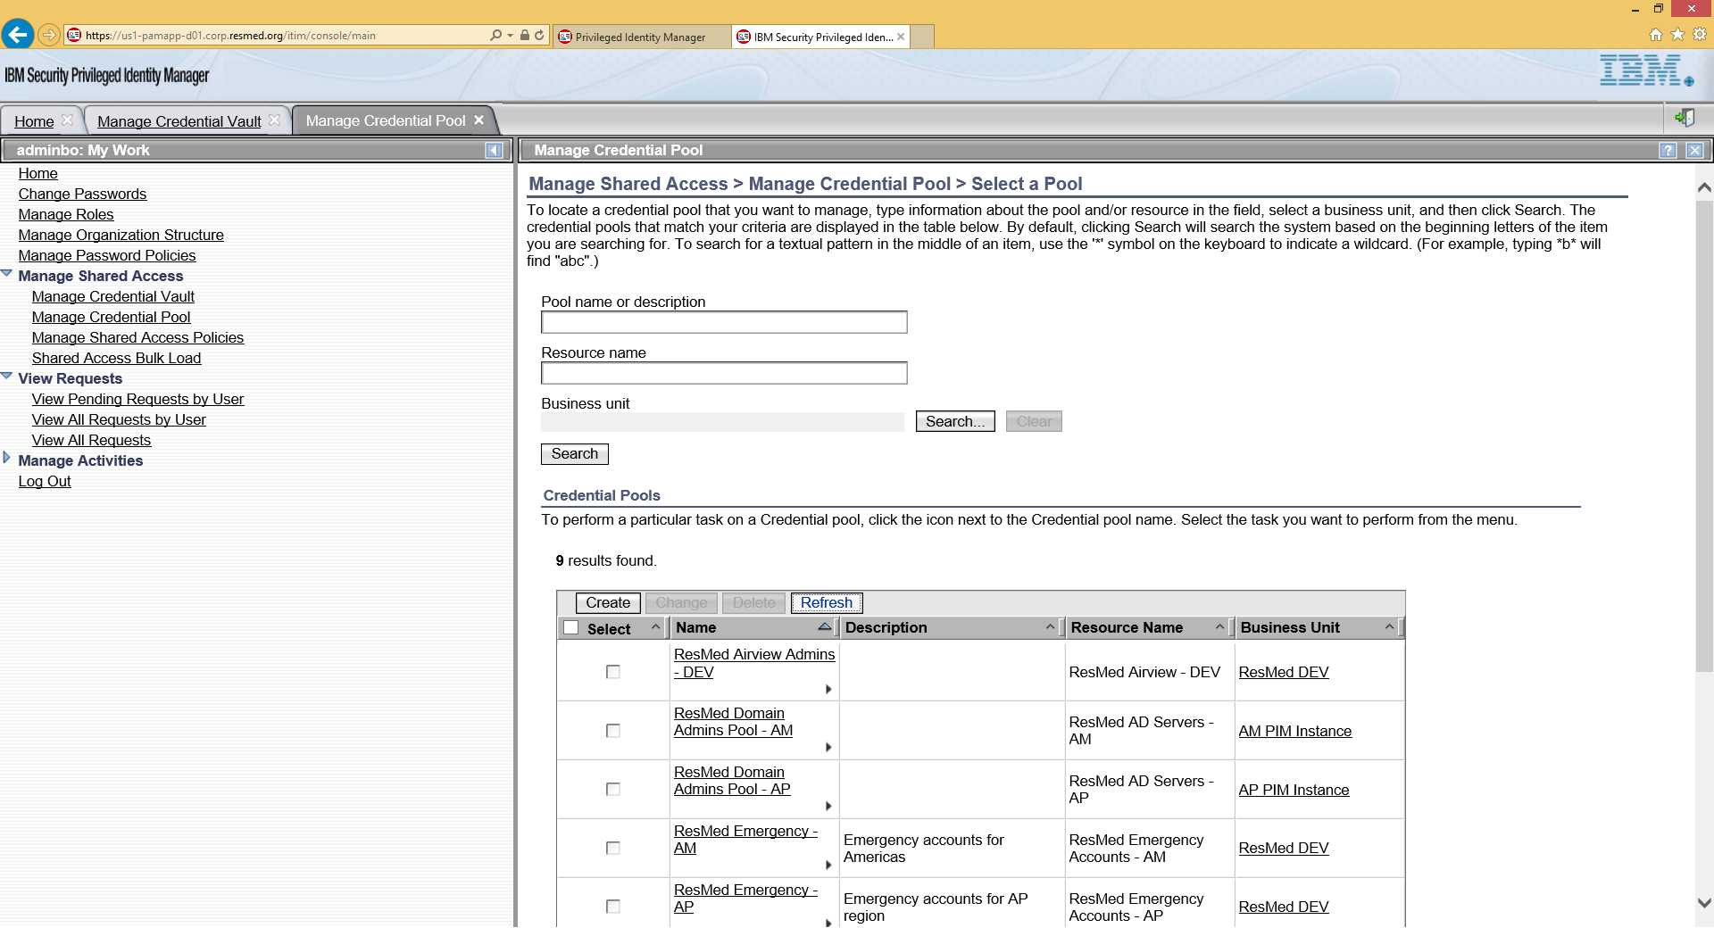

Figure 54. PIM Manage Credential Pool – Select Pool

1. Click **Create**.

The General Information page appears.

1. Enter the Pool Name and click **Search**.

This action associates the resource with the new pool.

For example:

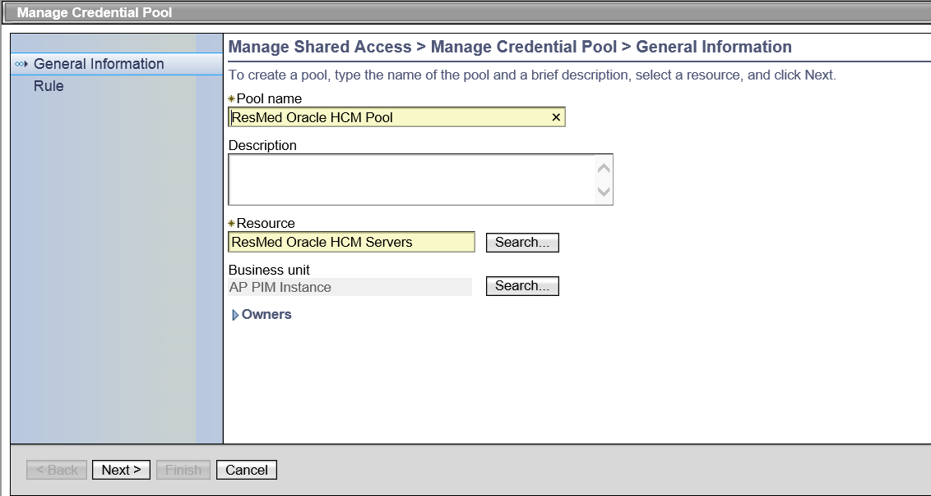

Figure 55. PIM Manage Credential Pool – Search

1. Click **Next**.
2. When the Rule page appears, click **Finish**.

For example:

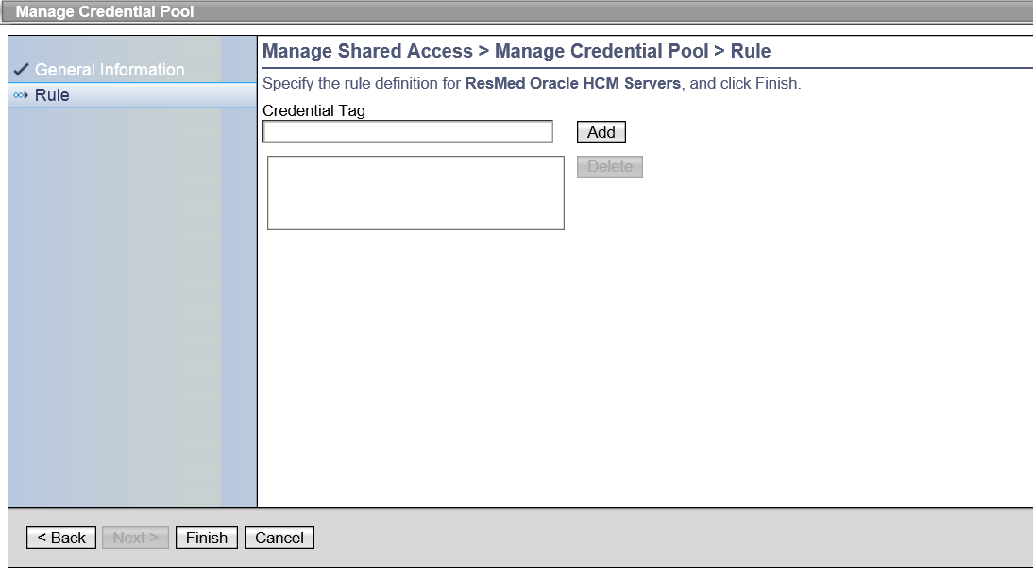

Figure 56. PIM Manage Credential Pool - Finish

1. When the success message appears, click **Close** to exit.

For example:

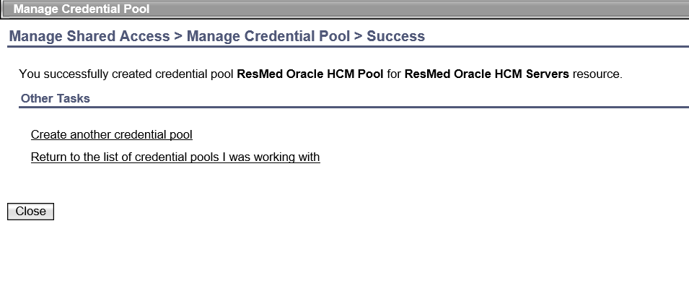

Figure 57. PIM Manage Credential Pool - Success

### Modify a Credential Pool

An Administrator can modify an existing credential pool.

To modify a pool:

1. Login to the PIM Console.

See section 5.1 Logging In.

1. On the Console page, select the **Manage Credential Pool** tab.
2. Under Credential Pools, select a pool and then, click **Change**.

For example:

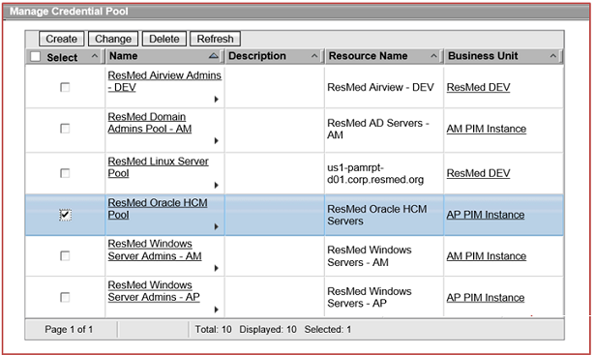

Figure 58. PIM Manage Credential Pool - Change Pool

A General Information for the selected pool appears.

For example:

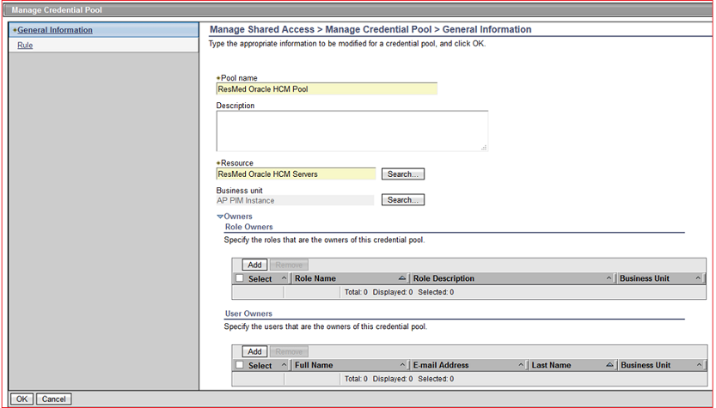

Figure 59. PIM Manage Credential Pool – Pool General Information

1. Change the selected pool.

An Administrator can change the designated Resource and add/delete Role Owners and User Owners associated with the credential pool.

* 1. To change the Resource
     1. Click Search to locate another resource.
     2. Click **OK**.
  2. To change the Role Owners:
     1. Check the box next to the Role Name.

You may select several names.

* + 1. Click **Add**.
  1. To change the User Owners:
     1. Check the box next to the Full Name.

You may select several names.

* + 1. Click **Add**.

1. Click **OK** to save your changes.

### View Credentials in a Pool

An Administrator can view credentials in a pool.

To view credentials in a pool:

1. Login to the Console.

See section 5.1 Logging In.

1. On the Console page, select the **Manage Credential Pool** tab.
2. Under the Manage Credential Pool section, click the arrownext to the pool name.



A pop-up menu appears.

For example:

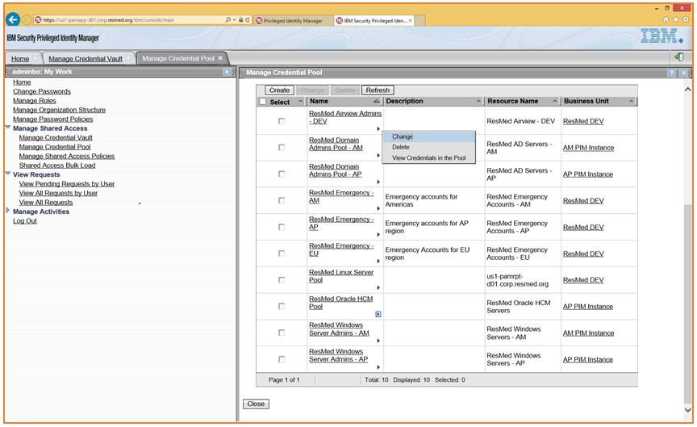

Figure 60. PIM Manage Credential Pool - View Credentials

1. Select **View Credentials in the Pool** in the pop-up menu.
2. When the next page appears, click the **Refresh** button to display pool information. For example:

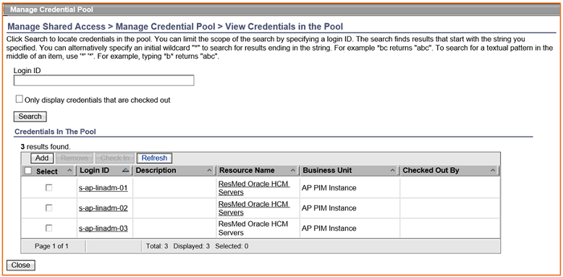

Figure 61. PIM Manage Credential Pool - View

### Bulk Loading Credentials into the Vault

Administrators can add new credentials into the vault by uploading a csv file. For a file description, see section 8.5 Bulk Upload CSV File.

To bulk load credentials into the vault:

1. Login to the Console.

See section 5.1 Logging In.

1. On the Console page, click the **Shared Access Bulk Load** link in the My Work section on the left.

The corresponding page appears. For example:

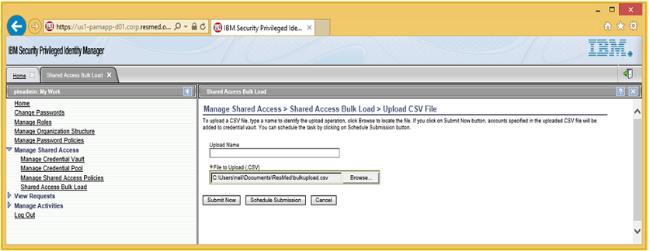

Figure 62. PIM Manage Credential Pool - Bulk Load

1. Click **Browse** to select the file to upload.
2. Submit the file upload.

You can upload the file now or at a later scheduled date/time.

* 1. To submit now, click **Submit Now**.

The upload is submitted.

* 1. To submit later, click **Schedule Submission**.

The Manage Shared Access > Shared Access Bulk Load > Upload CSV File > Confirm page appears.

For example:

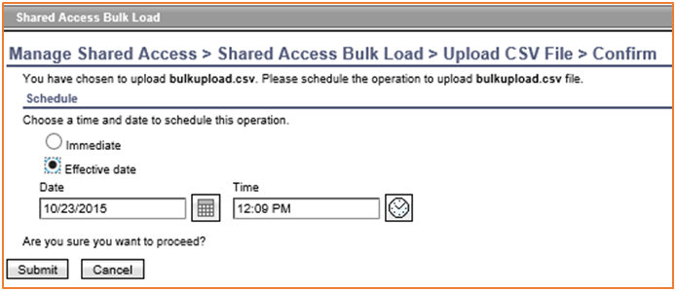

Figure 63. PIM Manage Credential Pool - Submit

* + 1. On the next page, select **Effective date** and then, select the **Date** and **Time**.
    2. Click **Submit**.

The upload will occur on the scheduled date/time.

## Managing Shared Access Policies

Administrators grant credential and credential pool access to PIM users through Shared Access Policies. This section explains how to create and disable shared access policies.

To view the available policies:

1. Login to the Console.

See section 5.1 Logging In.

1. On the Console page, select the **Manage Shared Access Policies** tab.
2. Click **Refresh**.

The Manage Shared Access Policies tab lists available policies. For example:

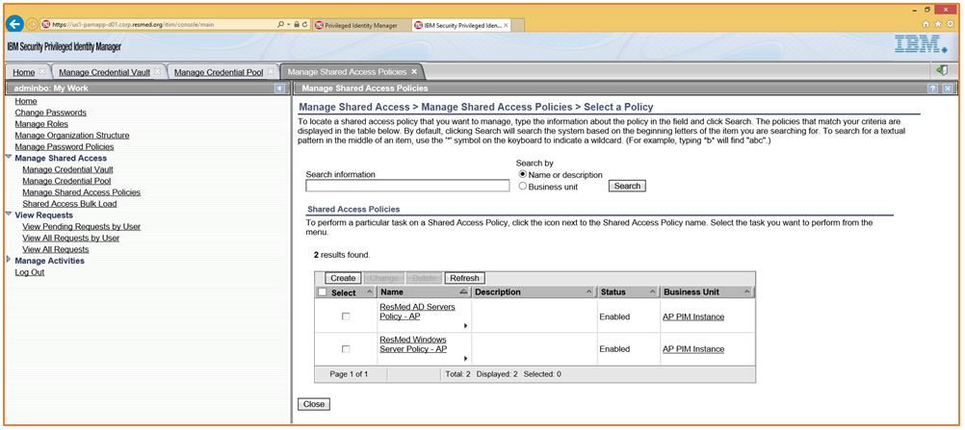

Figure 64. PIM Manage Shared Access Policies

### Create a Shared Access Policy

To create Shared Access Policy:

1. Login to the Console.

See section 5.1 Logging In.

1. On the Console page, select the **Manage Shared Access Policies** and then, click **Create**.
2. When the General page appears, enter Policy Name, set Policy Status to **Enable**, and click **Search** to select the Business Unit.

For example:

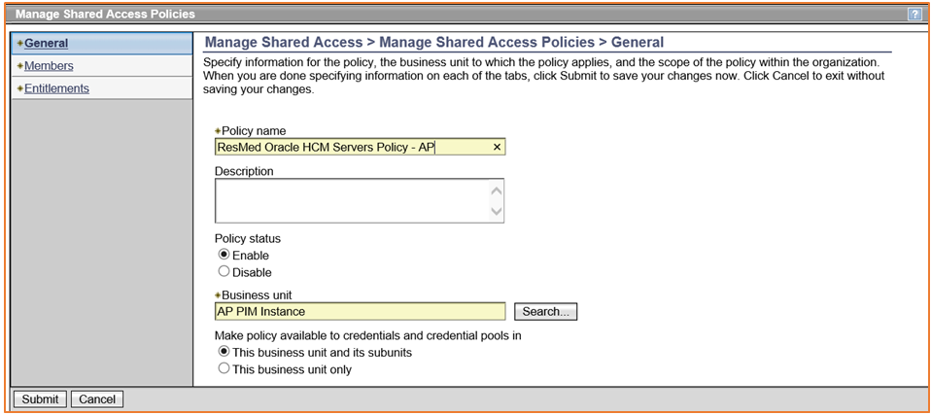

Figure 65. PIM Manage Shared Access Policies – Create - General

1. Select **Members** in the frame on the left.

The Members page appears.

1. Define Roles that can access the credentials.
   1. Select the **Member Type**.

You can select “All users” or specify the roles.

* 1. Click **Add**.

For example:

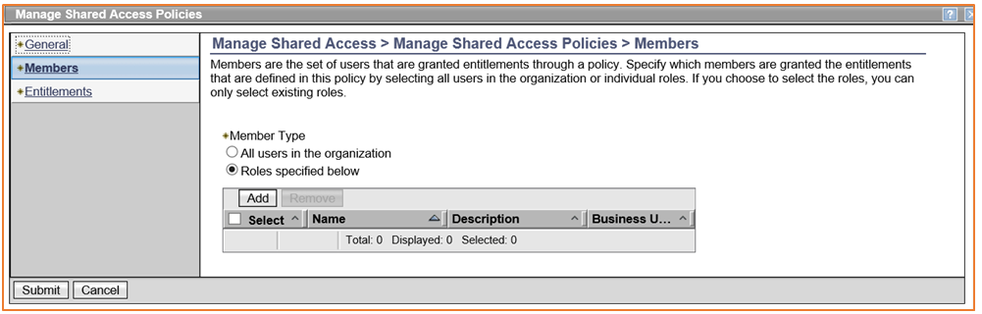

Figure 66. PIM Shared Access Policies – Create - Members

1. When the Roles page appears, select one or more roles and then, click **OK**.

For example:

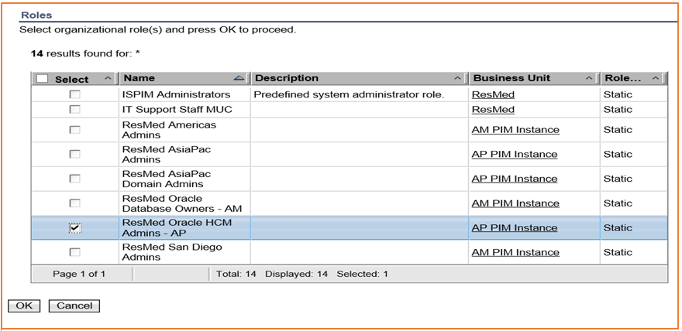

Figure 67. PIM Shared Access Policies - Create - Roles

1. Optionally, if you want to add more roles from the Members page. If not, go to Step 8, below.

See Figure 66. PIM Shared Access Policies – Create - Members.

1. Select **Entitlements** on the left.

The “Entitlements” page appears. For example:

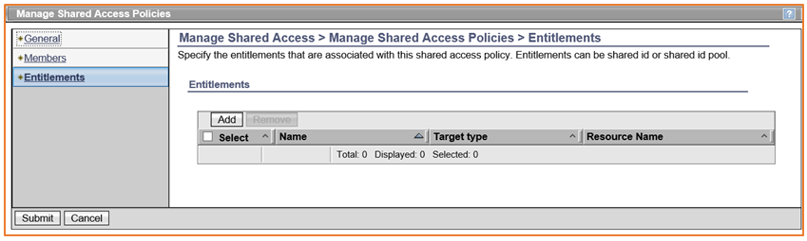

Figure 68. PIM Shared Access Policies - Create - Entitlements

1. Click **Add** to specify the credentials or credential pool to associate with this policy.
2. When the “Work With Entitlements” page appears, select the Entitlement Type (Credential or Credential Pool) and then, click **OK**. For example:

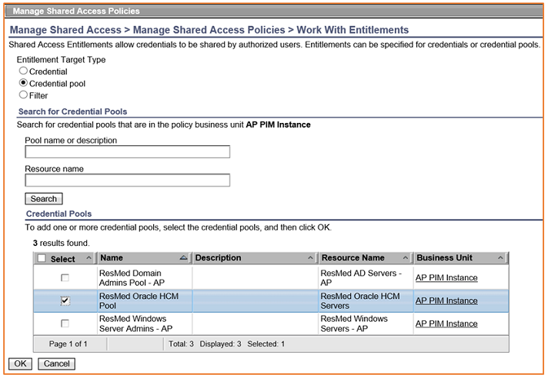

Figure 69. PIM Shared Access Policies - Work With Entitlements

The selected Entitlements are listed on the page. You can add more or delete some.

1. When the page changes, showing the new Entitlements, click **Submit**.

For example:

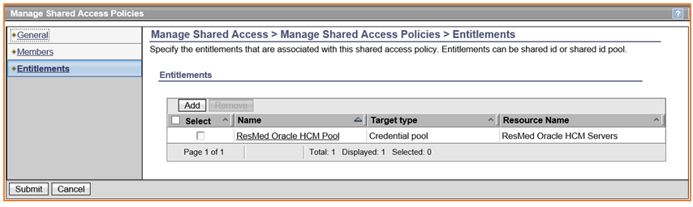

Figure 70. PIM Shared Access Policies - Submit Entitlements

1. Verify that the created policy is listed on the Shared Access Policies page.

For example:

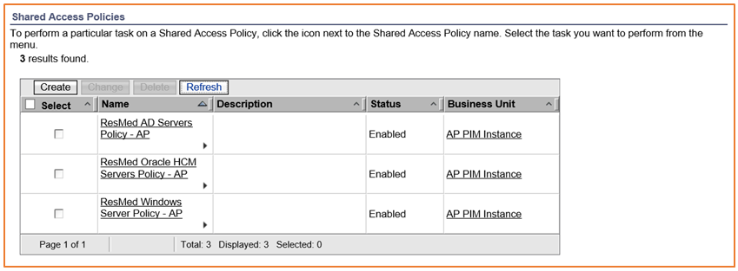

Figure 71. PIM Shared Access Policies - Verify New Policy

**Note**: Access Policies that were created using the PIM Service Center are listed but cannot be modified. In the following example, these policies are listed without check boxes.

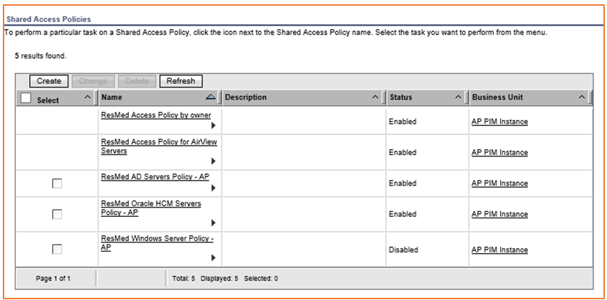

Figure 72. PIM Shared Access Policies - Policies Created in PIM Service Center

### Disable a Shared Access Policy

To disable a Shared Access Policy:

1. Login to the Console.

See section 5.1 Logging In.

1. On the Console page, select the **Manage Shared Access Policies**.
2. Select a Policy and click **Change**.

For example:

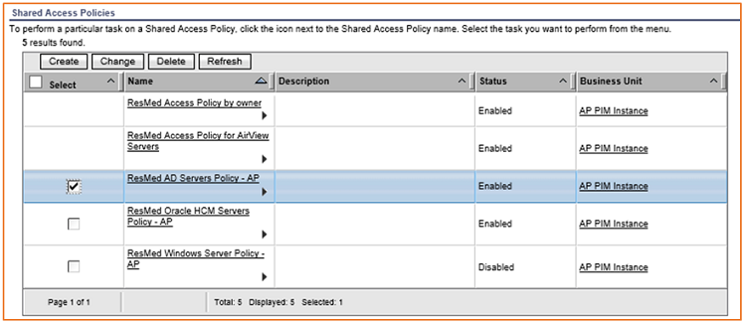

Figure 73. PIM Shared Access Policies - Disable Policy

1. When the General page appears, select **Disable** and then, click **Submit**.

For example:

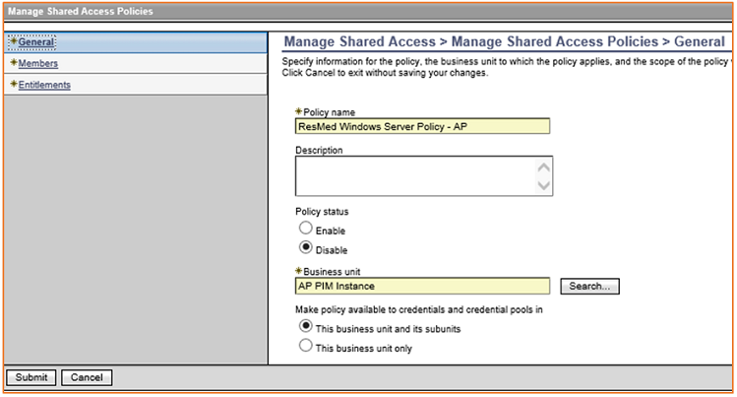

Figure 74. PIM Shared Access Policies - Disable Submit

## Managing Requests

The section focuses on managing requests. A request starts a workflow. Requests include these actions:

* Checking in/out credentials
* Changing account passwords
* Adding credentials to a vault
* Connecting a credential to an identity provider

The user who made a request can view it. A request may be in one of the states listed below.

|  |  |
| --- | --- |
| **State** | **Description** |
| Successful | The request was completed successfully. |
| Failed | The request could not be completed because of errors. |
| Pending Response | The request is waiting for a responder to complete the activity. |
| Pending Approval | The request is waiting for an approval. |
| Canceled | The request was canceled by the requestor. |
| Completed with warning | The request was partially completed. |
| In Process | The request is running and does not require any activity. |

### Viewing Requests

To view a request:

1. Login to the Console.

See section .

1. On the Console page, select **View Requests** > **View All Requests**.

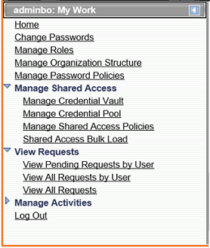

Figure 75. PIM Manage Requests - View Requests

1. When the “View Requests > View All Requests” page appears select Request Type and Time Interval.
2. Click **Search Requests**.

For example:

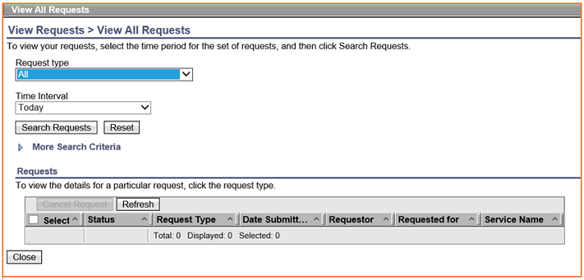

Figure 76. PIM Manage Requests - View All Requests

A Requests page appears listing requests in chronological order.

For example:

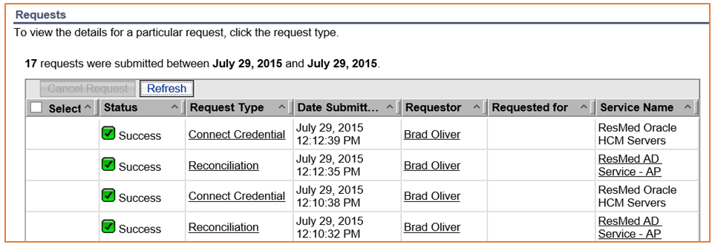

Figure 77. PIM Manage Requests - View All Requests List

1. Click on the Request Type to view more details. For example:

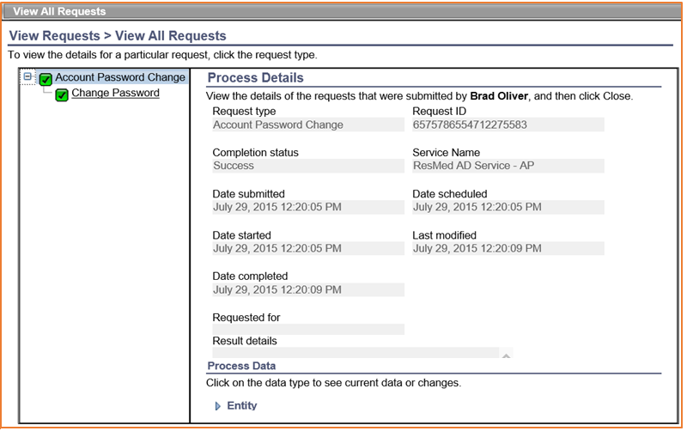

Figure 78. PIM Manage Requests - View All Requests Details

## Managing Users and Roles

Each user has a PIM account. Users can be assigned roles and added to groups for PIM activities or to access credentials stored in the PIM vault. This section explains how to create users and user roles.

### Creating Users

To create a user:

1. Login to the Console.

See section .

1. On the Console page, select **Manage Users**.

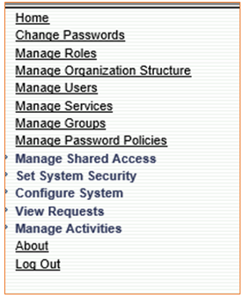

Figure 79. PIM Manage Users

The “Manage Users > Select a User” page appears.

For example:

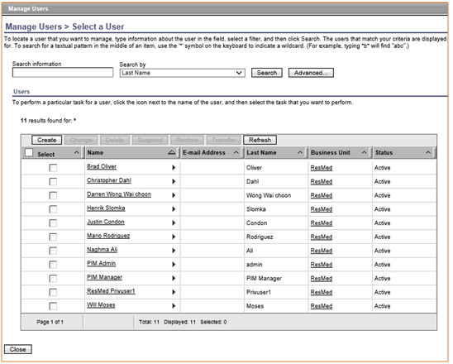

Figure 80. PIM Manage Users - List

1. Click **Search** to select a Business Unit and the, click **Continue**.

For example:

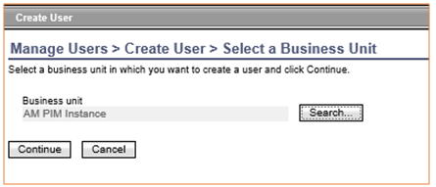

Figure 81. PIM Manage Users - Select Business Unit

1. On the Personal Information page fill in the Last Name, Full Name, and Preferred User ID fields and then, click **Continue**.

For example:

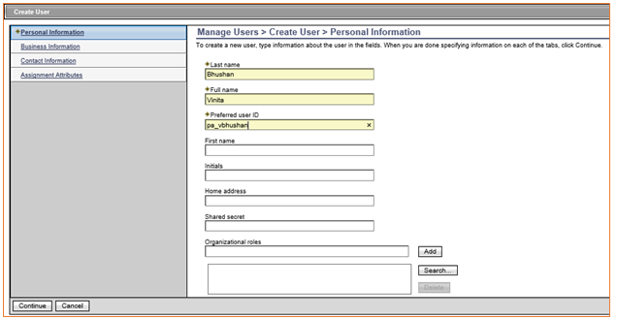

Figure 82. PIM Manage Users - Personal Information

1. On the Create New Password page enter a Password, Date and Time and then, click **Submit**.

For example:

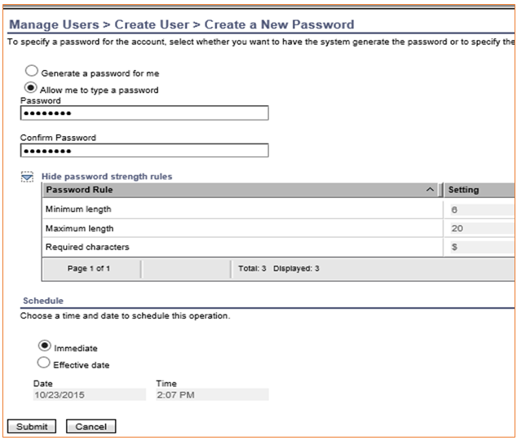

Figure 83. PIM Manage Users - Create Password

**Note**: To display the password policy, click on the **Hide Password Strength Rules** option.

**Managing Roles**

An Administrator can view user roles. A role identifies the task(s) that a user can perform; e.g., AD Administrators, IT Support Staff, Windows Server Administrators, and others.

In PIM a role identifies users that can access shared credentials. These roles are configured in a Shared Access Policy and then assigned to one or more pools. This section explains how to view and create user roles.

### View Roles

To view roles:

1. Login to the Console.

See section .

1. On the Console page, select **Manage Roles**.



Figure 84. PIM Manage Roles – Select Manage Roles

1. On the “Manage Roles” page click **Refresh**.

For example:

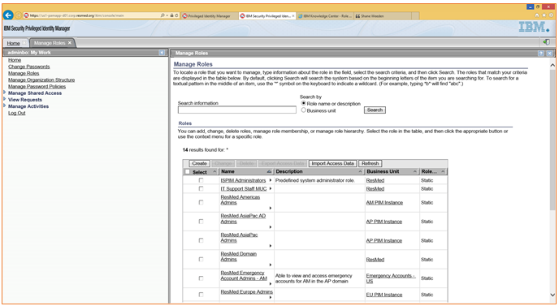

Figure 85. PIM Manage Roles Page

### Creating Roles

To create a role:

1. Login to the Console.

See section .

1. On the Console page, select **Manage Roles**.
2. On the Manage Roles page click **Create**.

For example:



Figure 86. PIM Manage Roles – Click Create

1. On the “Role Type” page select Role Type **Static** and then, click **Next**.

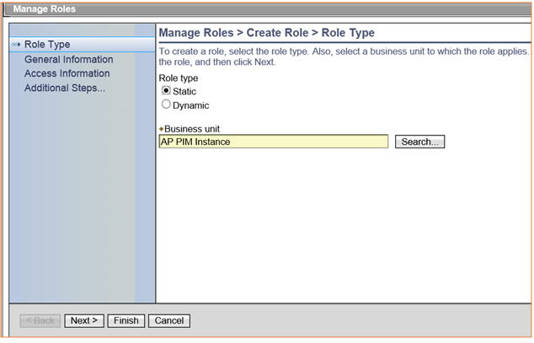

Figure 87. PIM Manage Roles - Role Type

1. On the “General Information” page fill in the Name and click **Next**. For example:

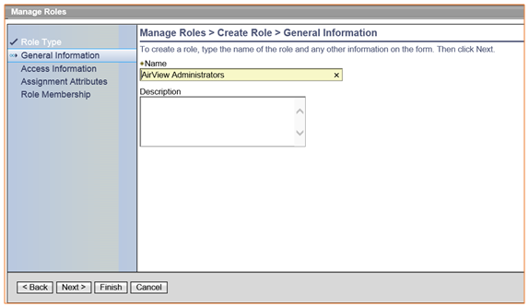

Figure 88. PIM Manage Roles – General Information

1. On the next page check **Enable access for this role** and then, click **Next**. For example:

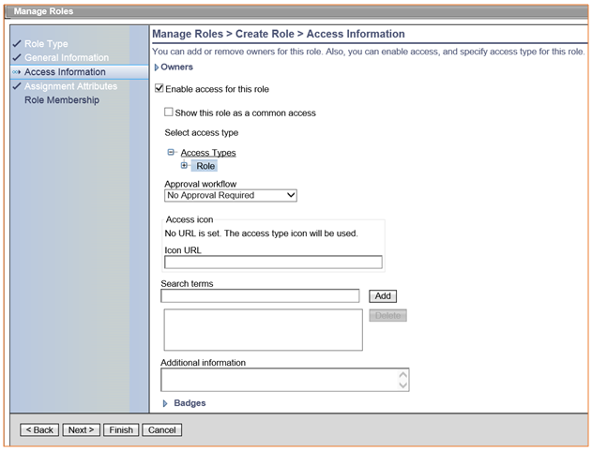

Figure 89. PIM Manage Roles - Access Information

1. On the “Assignment Attributes” page click **Next**.

**Note**: This page can be used to create a dynamic role based on the value of a user attribute such as “Title”.

1. On the “Role Membership” page, click **Add** to add users to the role and then, click **Next**.

Alternately, select users on the “Add Users” page. For example:

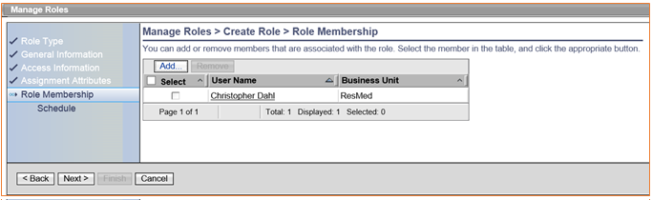

Figure 90. PIM Manage Roles - Role Membership

1. On the Schedule page select the **Immediate** option and click **Finish**.

Access Policy includes in the PIM Service Center. Each role can be modified by adding Entitlements.

For example:

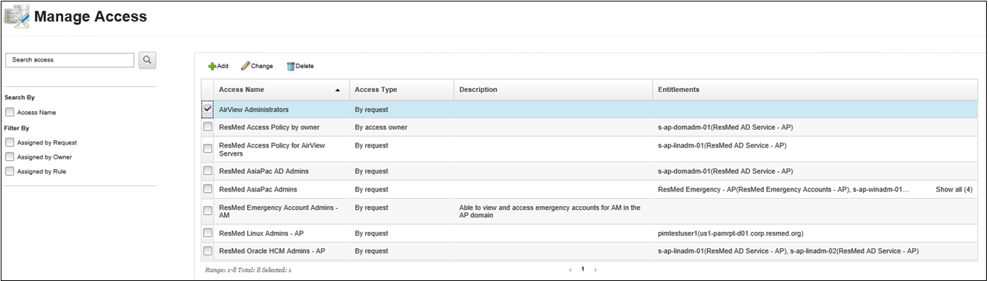

Figure 91. PIM Manage Roles - New Role Listed

# APPLIANCE DASHBOARD TASKS

The PIM Appliance Dashboard enables the PIM Administrator to configure settings and view logs and status information. This section explains how to logon and use the Dashboard to restart or shut down an appliance, configure a directory/database server, view logs, and manage clusters.

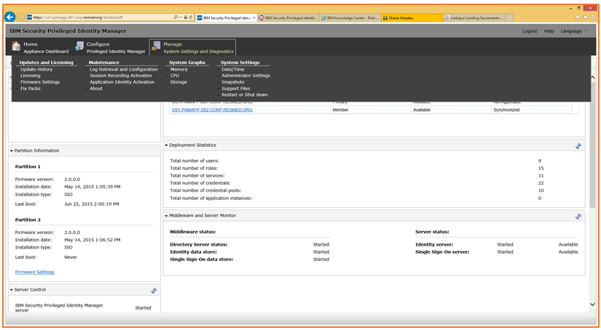

Figure 92. PIM Appliance Dashboard

## Log In

To login to the Dashboard:

1. launch the browser and go to

<https://FQDN> of Server.

1. On the login page, enter Admin for User Name. The Password was created when the system was setup.

For example:

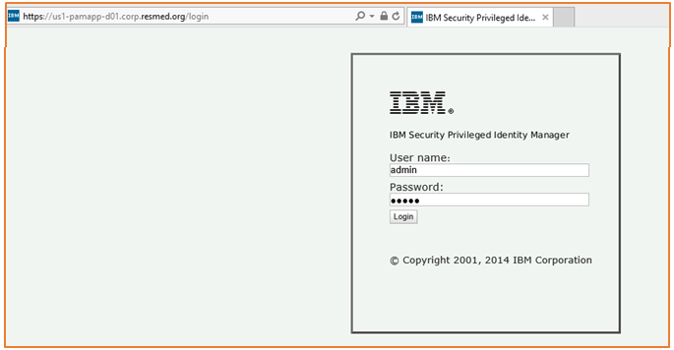

Figure 93. PIM Appliance Dashboard - Login

## Restarting or Shutting Down an Appliance

An Administrator can shut down or restart a Virtual appliance from the Dashboard.

To restart or shutdown an appliance:

1. On the Dashboard, select **System Settings** > **Restart or Shut down**.

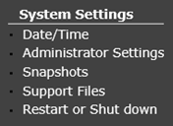

Figure 94. PIM Appliance Dashboard – System Settings

1. When the Server Control area appears, click **Restart** or **Stop** to restart or stop the appliance.

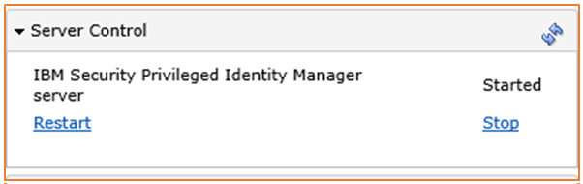

Figure 95. PIM Appliance Dashboard - Server Control

## Configuring Directory/Database Server

Ad Administrator can configure the LDAP or DB2 server from the Dashboard.

To configure the directory or server:

1. On the Dashboard, select **Configure** at the top.
2. On the next page, select **Directory** or **Database** or **Load Balancer** configuration.
3. Select the listed configuration and click **Reconfigure**.
4. Enter appropriate changes and click **Save Configuration**.

For example:

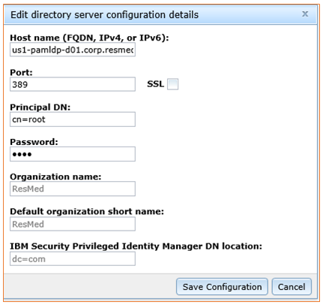

Figure 96. PIM Appliance Dashboard - Configure Details

## Viewing Logs

An Administrator can use the Dashboard to view logs for the appliance, session recorder, single sign-on, and identity management.

To view logs:

1. On the Dashboard, select **Manage** > **Maintenance** > **Log Retrieval and Configuration**.

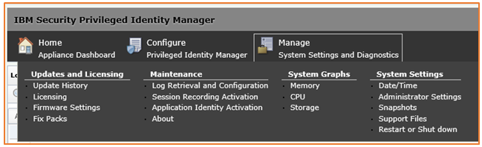

Figure 97. PIM Appliance Dashboard - Manage

1. On the “Log Retrieval and Configuration” page select the log file and then, click **View**.

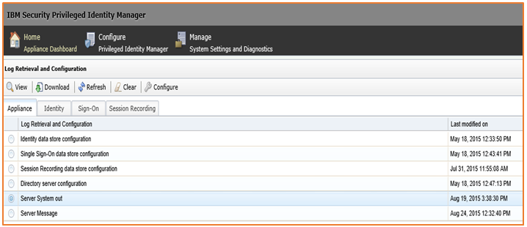

Figure 98. PIM Appliance Dashboard - Log Retrieval and Configuration

## Managing Clusters

An Administrator can use the Dashboard to synchronize two PIM appliances for failover protection. A cluster’s status can be viewed on the Dashboard.

For example:

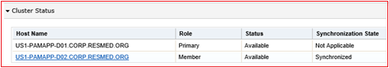

Figure 99. PIM Manage Clusters - View Status

In this example, the secondary node is in a Synchronized State.

### Manually Synchronize Clusters

To manually synchronize clusters:

1. Select **Configure** > **Cluster Node Configuration**.

For example:

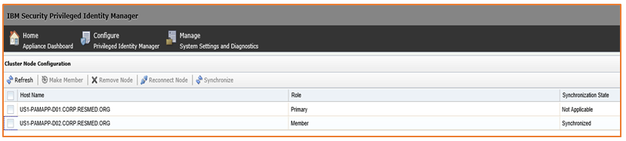

Figure 100. PIM Manage Clusters - Cluster Node Configuration

1. Select the secondary node in the list and click **Synchronize**.

# SESSION RECORDER CONSOLE TASKS

An Administrator can use the session recorder console to view recordings.

## Log In

To log in:

1. Open the browser and go to URL:

https://<FQDN of Server>/recorder/ui/.

1. In the Console, enter PIM Administrator credentials and click **Log In**.

For example:

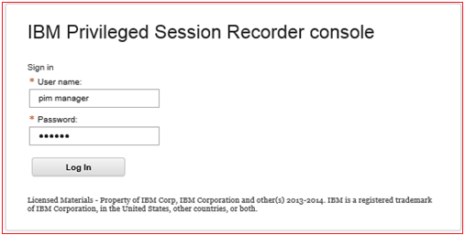

Figure 101. PIM Session Recorder - Log In

## View Session Recordings

To view a session recording:

1. On the Console, click on a listed recording and then, click **View Recording**. For example:

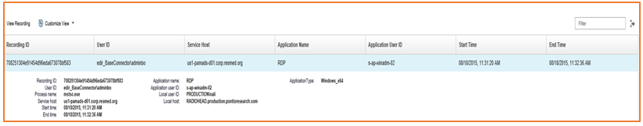

Figure 102. PIM Session Recorder - Select Viewing

1. When another window opens showing the recording location, click **Play**. For example:

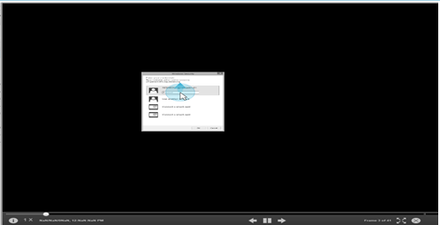

Figure 103. PIM Session Recorder - Recording Location

# APPENDIX

This appendix contains tables describing key PIAM configurations.

## PosixLinuxProfile

|  |  |  |
| --- | --- | --- |
| **Tab** | **Field** | **Value** |
| General Information | Service Name | Name of the service; e.g., RsMd Linux Service. |
|  | Tivoli Directory Integrator location | rmi://us1-pamldp-d01.corp.RsMd.org:2099/ITDIDispatcher |
|  | Authentication Mode | Admin |
|  | Managed Resource location | The FQDN of the Linux server that needs to be accessed; e.g., us1-pamrpt-d01.corp.RsMd.org |
| Authentication | Administrator Name | A user account that has admin privileges like root |
|  | Is Sudo User | Enable this check box if the administrator defined above has pseudo privileges |
|  | Authentication method | Select either password or key based |
|  | Password | Enter the password of the administrator if the authentication method selected is Password |
|  | Passphrase | Enter the passphrase if the authentication method selected is key based |
|  | Private Key file | Provide the path to the private key file if the authentication method selected is key based |

## ADProfile

|  |  |  |
| --- | --- | --- |
| **Tab** | **Field** | **Value** |
| Active Directory Service | Service Name | Name of the service; e.g., RsMd AD Service. |
|  | URL | The FQDN of the server where the AD adapter has been installed. http://us1-pamads-d01.corp.RsMd.org:45580 |
|  | User ID | User ID defined within the adapter; e.g., agent. |
|  | Password | Password of the adapter user account. E.g.: agent |
|  | Users Base Point DN | The distinguished name of the container in AD where the user accounts are stored; e.g., OU=PIAM Dev,OU=Global,DC=corp,DC=RsMd,DC=org |
|  | Administration User Account | The account that has the permissions to make changes to the user accounts in AD. It can be service account which mainly has password management privileges in AD. |
|  | Administration User Password | Password of the Administration User Account |

## WinlocalProfile

|  |  |  |
| --- | --- | --- |
| **Tab** | **Field** | **Value** |
| Active Directory Service | Service Name | Name of the service; e.g., RsMd Windows Server Service |
|  | URL | The FQDN of the server where the WinLocal adapter is installed. http://us1-pamads-d01.corp.RsMd.org:45581 |
|  | User ID | User ID defined within the adapter; e.g., agent |
|  | Password | Password of the adapter user account; e.g., agent |
|  | Workstation | The FQDN of the Windows server that needs to be accessed; e.g., us1-pamads-d01.corp.RsMd.org |

## Configuring Shared Access Workflows

To configure a Shared Access:

1. Use the PIM Service Center to create an Identity Provider. The provider may be a one-time configuration; for example, Active Directory.

See section 4.1 Creating Identify Providers.

1. Use the PIM Service Center or PIM Administration Console to add a resource.

See section 4.2 Managing Resources.

1. Use the PIM Service Center or PIM Administration Console to add new credentials.

See section 4.3.1 Add New Credentials.

1. Use the PIM Service Center or PIM Administration Console to create a Shared Access Policy.

See section 4.4 Managing Access or 5.4 Managing Shared Access Policies.

## Bulk Upload CSV File

A shared access CSV file contains the type identifier, column headers, and code.

1. Type Identifier: This is the first line in the file. For PIM version 2.0 and above the type identifier is #Credentials_V2 or #CredentialPools_v2 if uploading pooled accounts.
2. Column Headers: These are attribute names which Include
   1. ACCOUNT_UID: Required attribute and specifies the user ID
   2. ORG_PDN: Specifies the container DN. Example, “ou=AM PIM Instance,OU=RsMd DEV,O=RsMd”
   3. RESET_PASSWORD: Optional attribute, and specifies whether the password must be reset after adding it to the vault. Valid values are TRUE and FALSE.
   4. PASSWORD: The password of the account.
   5. DESCRIPTION: Optional attribute that describes the account
   6. USE_DEFAULT_SETTINGS: Optional attribute to specify if the default credential settings need to be applied or not. Valid values are TRUE and FALSE
   7. ACCESS_MODE: Optional attribute if USE_DEFAULT_SETTINGS is FALSE. Specifies the access mode of the credentials with values like
      1. 0- Requires check-in and checkout
      2. 1- Does not require check-in and checkout
      3. 2 – Credential is not shared
   8. PASSWORD_VIEWABLE: Specifies whether to display the password to users on the self-service console. Values are TRUE and FALSE
   9. MAX_CHECKOUT_DURATION: Specifies how long a credential can be checked out.
      1. 8w – indicates 8 weeks
      2. 8d – indicates 8 days
      3. 8h – indicates 8 hours
   10. ENABLE_CHECKOUT_SEARCH: Specifies whether the checkout search is enabled for the credential on the self-service console. Values are TRUE or FALSE
   11. RESET_PASSWORD_ON_CHECKIN: Specifies if the password must be changed after the account is checked in. Values are TRUE or FALSE.
   12. RESOURCE_UID: Resource identification for which the credentials are being added. It could be a URL or an IP address
   13. RESOURCE_NAME: Optional attribute specifying a common name of the resource, like ALL RsMd Servers
   14. CONNECT_SERVICE_DN: Specifies the DN of the service to which a credential needs to be connected so a password reset can happen during check-in. Example: “description=RsMd AD Service,ou=AM PIM Instance,ou=RedMed DEV,o=RsMd”

Here is a sample CSV file:

#Credentials_v2,

ACCOUNT_UID,ORG_PDN,PASSWORD,RESET_PASSWORD,DESCRIPTION,ACCESS_MODE,PASSWORD_VIEWABLE,MAX_CHECKOUT_DURATION,ENABLE_CHECKOUT_SEARCH,RESET_PASSWORD_ON_CHECKIN,RESOURCE_UID,RESOURCE_NAME

pa_test2,"ou=AM PIM Instance,ou=RsMd DEV,o=RsMd",P@ssw0rd,FALSE,named account,1,TRUE,8h,TRUE,FALSE,*.corp.RsMd.org,All RsMd Servers